Buyers’ Delivery Email Funnel Template

If you need a reminder what email funnel is what, we HIGHLY recommend you read through the What is an Email Funnel? Explanation: https://howtocreatearetreat.s3.amazonaws.com/marketing-mastery/WhatisEmailFunnelMMA.docx

Your Buyers’ Email Funnel is what you send to folks who have enrolled in your online program.

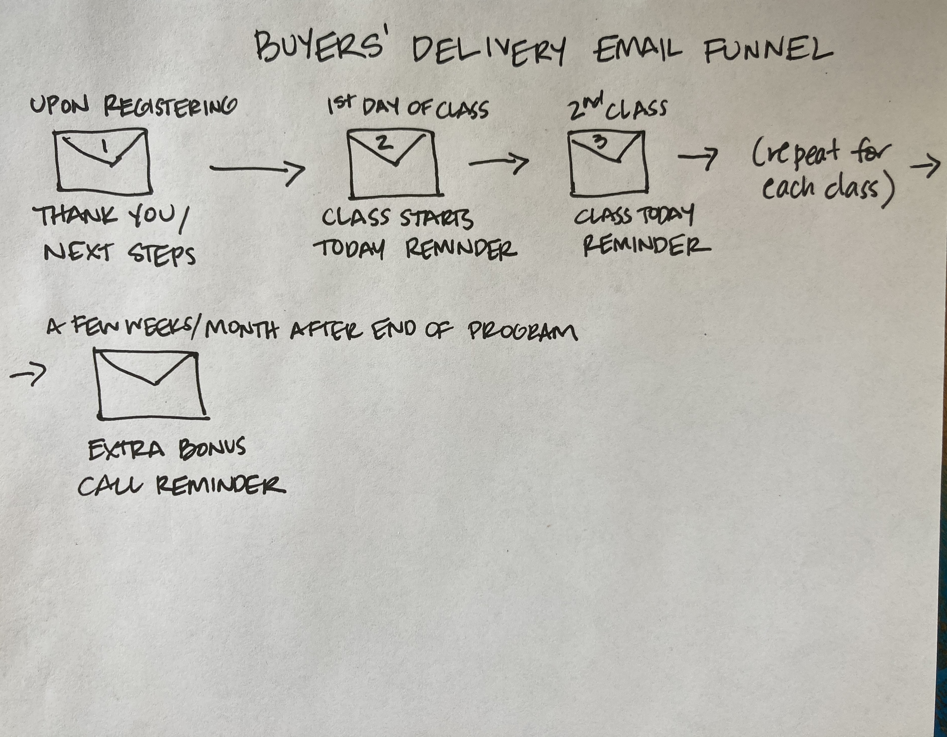

This is where you welcome folks into your online program. Yeah, sales!

You’ll want to explain the details of the “next steps” after registering for your program. Depending on what you included in your online program that might include coming into

your Buyer’s Facebook Group, marking the dates of group calls on their calendar, scheduling a 1:1 session with you or logging into your online program.

It’s also smart to send reminder emails for each live group call you have to keep people re-engaged. Remember that the more folks participate in your program, the more success they’ll have – which means less cancellations and more testimonials for you.

If you want to go the extra mile, some coaches send out a “class is tomorrow” reminder email and then a “class is today” one. You may also want to send out replay emails with homework reminders after each call.

CRITICAL! You’ll want to make sure that as soon as anyone BUYS your online program that they are taken out of your WARM-UP or INVITE Email Funnel because they no longer need to receive any more sales emails.

We have given you examples of the simplest buyers’ delivery email funnel below and instructions at the end of this document. Simply add in as many as you need for your program depending on how many classes you have. Do make sure you have changed out the dates to match your program.

BUYERS’ DELIVERY EMAIL FUNNEL

BUYERS DELIVERY EMAIL 1: THANK YOU FOR PURCHASING/NEXT STEPS
Subject: Thank you for purchasing Marketing Mastery Academy Group Coaching Program!
Date: This gets sent out as soon as they purchase your online program

Hi ~Contact.FirstName~,
Awesome sauce! I see you’re ready to learn marketing from soup to nuts and get the skills you need to take your business to the next level. And we can’t wait for our live Implementation Calls to meet you…

Next 4 Steps:
1. Program Log-in: You will be getting a SEPARATE email from us with your PASSWORD to log into the program - it often goes to spam so please make sure you look there for it!
When you log in you will see this information on the page. YOU MUST CLICK the link that says "/members-home-mma" that we have illustrated in the picture below to enter the actual program!

2. Watch Welcome Video
Once you get your log-in, pop on over to the Members Home page - we have a special welcome video for you that tells you how to get the most out of the program.
3. Mark Your Calendar for the implementation calls!
December 18th @7pm New York time
January 15th @12pm New York time
January 22nd @7pm New York time
February 5th @12pm New York time
February 19th @7pm New York time
March 11th @12pm New York time
March 25th @7pm New York time
April 8th @12pm New York time
April 22nd @7pm New York time
Here’s a handy-dandy Time Converter to figure out what time that is for you.
***Keep in mind that the time changes for our LAST class in some countries due to daylight savings - so please make a note it this!
4. Join Our Marketing Mastery Academy Private Facebook Group
Hop over to introduce yourself, ask questions and receive feedback on your retreat here:
Marketing Mastery Academy Facebook Group
[insert link to your BUYERS’ FACEBOOK GROUP]

IN CASE YOU'RE WONDERING
Essentially, a new module will open every other week until all 8 modules are completely open. All the worksheets for each module will appear when that module opens.
Implementation calls are so that we can coach you one-on-one live, so make sure you bring your questions and challenges. Although we plan on those calls to be around 2 hours we will NOT leave until everyone has had their question addressed! Those calls will be recorded and posted the next day.
Implementation calls will be on Zoom so that we can see each other and talk to each other. Make sure you have a headphone so that we do not get feedback when you are live. You’ll get a reminder for the call that day.
The Zoom link is: https://zoom.us/j/871140829
You are all set! Thank you SO MUCH for joining us!
To your wanderlust life, Sheri & Meghan + The Wanderlust Team

PS: Here is our cancellation policy for your files. PLEASE READ THIS CAREFULLY:
I understand that with this transaction, I am PURCHASING this program in FULL. I am clear that I am NOT purchasing a monthly subscription plan that I can cancel at any time, but instead, agreeing to pay in FULL (with the opportunity to do so over time, with interest, if I am choosing a payment plan).
I understand that I have 30 days from the date of purchase to review and use the first two course modules. To be eligible for a 100% REFUND of my tuition, I understand that I must submit my completed homework from MODULE ONE in the course Facebook Group to demonstrate that I did the work.
I understand that chargebacks are NOT an acceptable way to cancel this program and will be contested - and that I MUST submit my homework within the 30 days as stated above to receive my full refund.
Please be advised that the content of this course - including but not limited to the videos, worksheets, files, forms, documents and spreadsheets contained herein - is protected under copyright law and the copyright held by Sheri A Rosenthal DPM Inc. dba Wanderlust Entrepreneur.
It is illegal to share, copy or re-purpose any of the materials herein for your own commercial use or with other individuals. These materials are for your personal use only unless you obtain prior written consent of Sheri A Rosenthal DPM Inc. to the contrary.

BUYERS DELIVERY EMAIL 2: CLASS STARTS TODAY!
Subject: Our Marketing Mastery Academy Implementation call is TODAY!
Date: Send this out on the day of your first group call

Hi ~Contact.FirstName~,
REMINDER TIME!
Our first Implementation Coaching call is TODAY October 30th @7pm New York time.
To figure out the time in your area use this handy link. [insert your time converter link.]
Implementation calls are so that we can coach you one-on-one live, so make sure you bring your questions and challenges.
ALL calls will be recorded and posted the next day. Implementation calls will be on Zoom so that we can see each other and talk to each other. Make sure you have a headphone if possible so that we do not get feedback when you are live.
The Zoom link is: [INSERT YOUR ZOOM/CLASS LINK]

2. MAKE SURE YOU ARE IN OUR FACEBOOK GROUP:
[insert your BUYERS’ Facebook Group link]
To your wanderlust life & business, Sheri & Meghan

P.S. Have you marked your calendar?
November 6th @12pm New York time
November 20th @7pm New York time
December 4th @12pm New York time
December 18th @7pm New York time
January 15th @12pm New York time
January 22nd @7pm New York time
February 5th @12pm New York time
February 19th @7pm New York time

March 11th @12pm New York time
March 25th @7pm New York time
April 8th @12pm New York time
April 22nd @7pm New York time
To figure out the time in your area use this handy link. [insert your time converter link.]

BUYERS DELIVERY EMAIL 3: NEXT CLASS TODAY!
Now add in as many call reminders as you need depending on the number of classes in your program.

Subject: Our Marketing Mastery Academy Implementation call is TODAY!
Date: Send this out on the day of your second group call (and repeat)

[Use the email above with edited dates.]

LAST BUYERS DELIVERY EMAIL: WE’RE NOT DONE YET!
It’s smart to have one extra call a few weeks or months after your program ends so you can check on your participants’ progress and tell them about how they can continue to work with you, whether it’s with 1:1 coaching or in another online program.

We tell folks about this surprise call on the last class in the program and then send out a reminder before the actual call date.

Subject: An MMA surprise for you! Whoot!
Date: A few days before your bonus call which is usually a few weeks or months after your program ends.

Hi ~Contact.FirstName~,

Are you missing us yet??? We hope so because our surprise bonus call is coming up and we miss all of YOU very very much. <3
Here are the deets: The bonus call is on Thursday, August 13th from 6-8pm New York time.

The link to join us is the same as always:
https://us02web.zoom.us/j/871140829
Can't wait to hear how you are doing and we'll be answering any questions and catching up.
Big hugs!
We are so proud of you! xoxoxox
To your wanderlust life + business,
Sheri, Meghan + the Wanderlust Entrepreneur Team

If you have any questions about your Buyers’ Delivery Email Funnel, please let us know!

