Challenge Sales Email Funnel Template

Horray! By now, you’ve should have already created your Warm-Up Email Funnel (with your welcome email) and your invite email funnel to your list if you have one (with a re-engagement email if needed). Both of these talked about your CHALLENGE.

Now it’s time to add in your Post-Pitch Sales Email Funnel where you are going to talk about your ONLINE PROGRAM.

If you need a reminder what email funnel is what, we HIGHLY recommend you read through the What is an Email Funnel? Explanation: https://howtocreatearetreat.s3.amazonaws.com/marketing-mastery/WhatisEmailFunnelMMA.docx

The whole point of doing your pre-launch warm-up strategy – a challenge, webinar or event, is to sell people into your online program, right?

So at the end your challenge, you need to send out a Post-Pitch Sales Email Funnel (also called a Sales Funnel). It’s not worth doing a challenge unless you are going to send follow-up sales emails!

You are going to be telling two groups of people about your online program: those who participated in your challenge and everyone else on your list who did NOT register for the challenge.

For those who participated in your challenge, just because they heard your pitch during your challenge doesn’t mean they are ready to buy! Many participants will need to see what your online program includes in writing and hear about it multiple times before they are ready to register.

And for those who are on your list and DIDN’T register for your challenge, they may still be interested in the program itself. So capture every sale!

The good news is that you can write one set of emails for your challenge participants and with a slight edit you’ll have the second set for your entire list who DIDN’T register for the challenge done.

Then you are going to ADD these sales emails in to the end of your Warm-Up Email Funnel and the end of your Invite Email Funnel in your autoresponder. Make sure you re-publish!

Remember when you are writing an email funnel you want to:
- Address your clients’ pain points and how that relates to your PROGRAM promise and benefits
- Overcome any objections your client may have around joining your PROGRAM or buying into the idea of your promise in general
- Write in conversational everyday language like you are speaking to your best friend over coffee. Do not use practitioner speak!
- Mix up the type, length and style of your emails. Notice how we re-use some info without making it seem like it’s exactly the same.
- Add a tantalizing subject line for each email
- Don’t forget to add a fun royalty free photo in your emails!

We have given you examples of each email below and instructions at the end of this document. Don’t get fancy – just use our template and replace your info with ours! Do make sure you have changed out the dates to match your program.

POST-PITCH SALES FUNNEL TO YOUR CHALLENGE PARTICIPANTS
You are going to send out emails to your challenge participants letting them know about your online program. You’ll want to refer to your challenge and make the connection to how your online program is the logical next step in solving their problem and working with you.

You are going to add in these emails at the end of your WARM UP EMAIL FUNNEL. Then make sure you re-publish it in your autorepsonder.

Take a good look at emails 10 – 12 below. These are your sales emails!

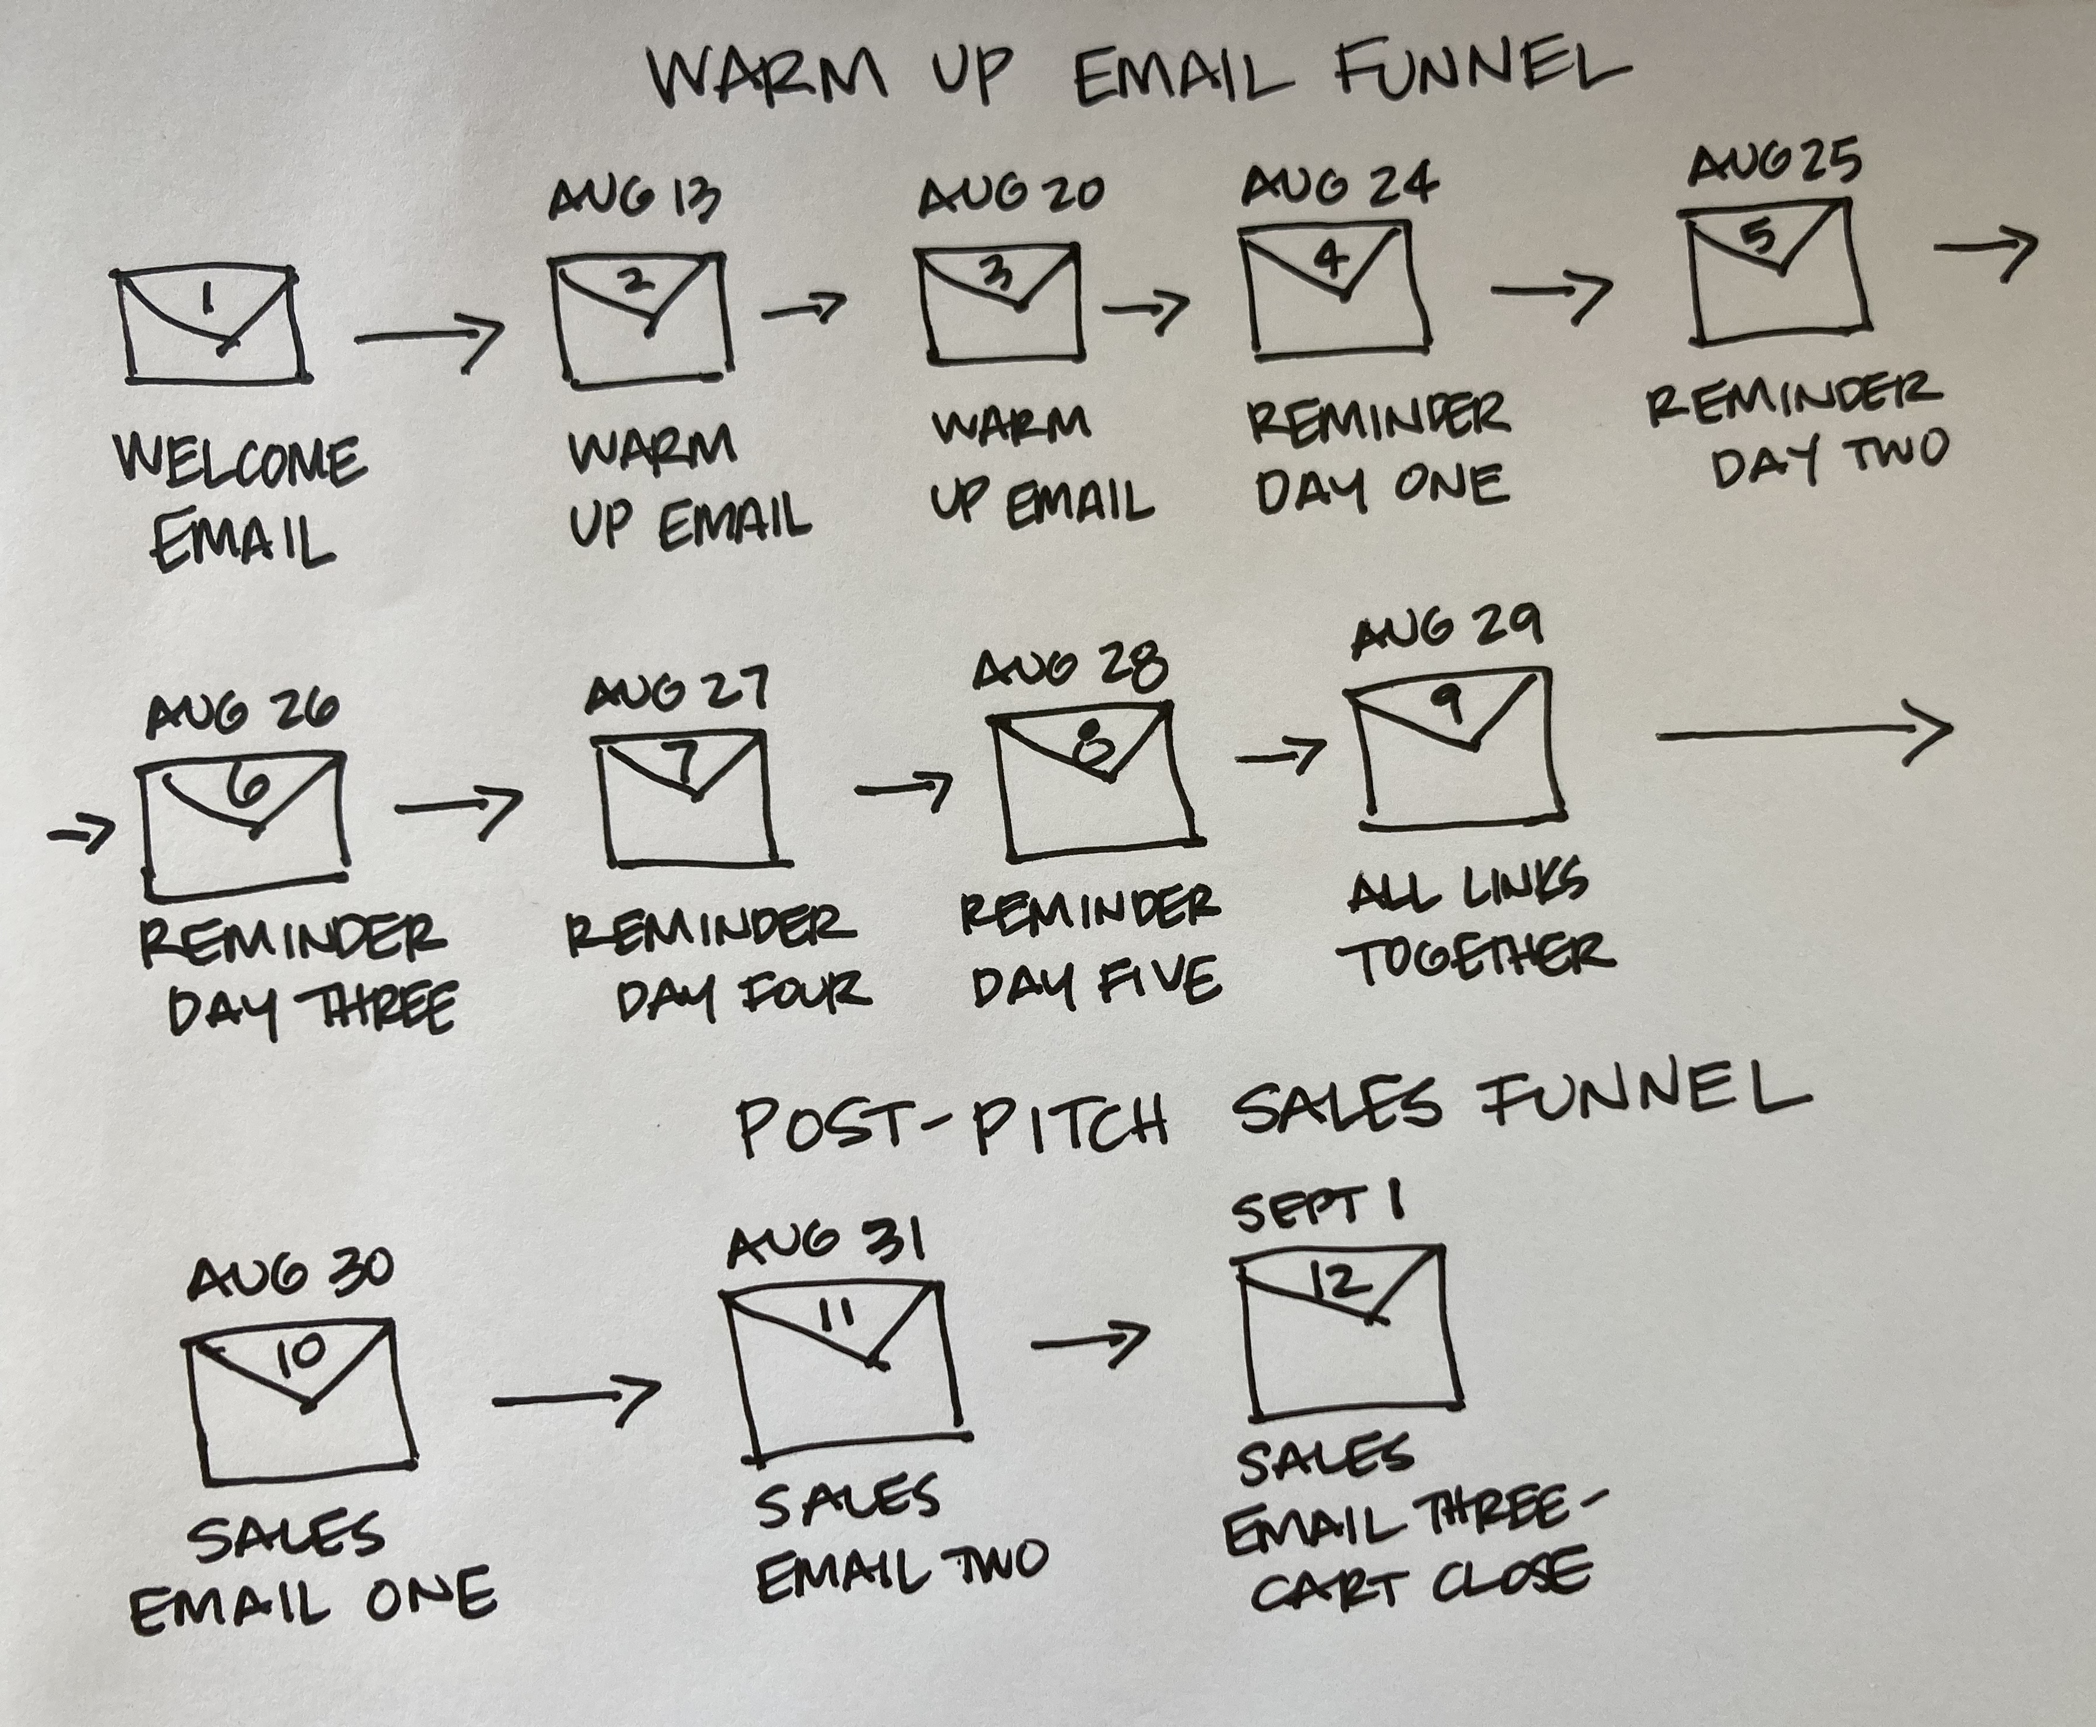

EMAIL 10 ADDED INTO YOUR WARM-UP EMAIL FUNNEL: SALES EMAIL 1

Subject: You did the challenge, now it's time to stop gnashing your teeth over marketing
Preview: ...no more being confusing, overwhelming, dreadful, or fake
Date: Assuming you started your challenge August 24th, you would send this on August 30th

Hi ~Contact.FirstName~,

Now that you did our 5 day challenge, how do YOU feel about marketing?
I want the honest TRUTH!
Because folks are telling us that marketing still feels “confusing, overwhelming, annoying, dreadful, fake, frustrating, time-consuming, boring, stressful…” to them.

And truly, I can SO relate. So let's fix this.

Now that you have the 5 P's in place, let's get you the marketing guidance you need - so join us for our....

Marketing Mastery Academy
Group Coaching Program!

I remember clear as day the first successful online product launch sales that I ever made. After investing $5000 in Facebook ads (gulp!) and hosting my first webinars, I opened my inbox and there was notices of money in the bank.

I thought I would cry with joy! $59,913 in bank from selling 29 programs.

That risk doubly paid off when I successfully filled my retreat 12 months later from all the new folks I added to my list from my webinars.

Now not all our clients choose to do Facebook ads, online programs and webinars, but what ALL the successful ones have done is to invest in creating their own customized

marketing plan and implementing it so that becomes their go-to strategic plan for what to do each day, week, month and year.

If you’re ready for some hand-holding, step-by-step, advanced marketing training, then I invite you to join our:

Marketing Mastery Academy
6-month, In-depth, Step-by-Step, Marketing Program
Starting October 30th

BUTTON: Tell me more Sheri! [link to program sales page]

The Details:
- Our Live Interactive Implementation Coaching calls start on October 30th and run through April 22nd 2020 (you can always catch a replay).
- You'll get our over-the-top personalized feedback + coaching (which we're known for!) on our LIVE Implementation calls and in our private Facebook group for 6 months (so you can actually get your marketing DONE).
- All the skills you need are in the 8 online modules AND THEN we're there to help you apply those skills to your business during the 13 Live Implementation Coaching Calls and in the FB group. These calls are 100% coaching you, answering your questions, and working through your marketing needs.
- We’ve purposefully designed the program for our heart-centered folks who are ready to do more advanced marketing… this is a holistic, comprehensive program that walks you through how to connect all aspects of your marketing.
Not sure if this program is for you? We're happy to hop on a call with you here: http://bit.ly/MMAtalk [link to your calendar for a clairty/sales call]

BUTTON: Yes I’m ready to sign up! [link to program sales page]

If Christine could learn and implement what she needed to be able to reach more clients online - so can you!

[insert client testimonial about working with you if you have one]

We’ve made the investment as affordable as possible....
So let’s stop dreaming about running retreats and creating a business that’s ready to fill them – it’s time to actually DO the important work of getting clear on your people, problems, positioning and then move on to a marketing plan and develop the skills you need to be a marketing pro when it comes to promotion.
You know we’d love to work with YOU.
To your wanderlust life and business, Sheri, Meghan + The Wanderlust Team

PS: During the program, you’ll:
- Know exactly what focused, productive actions to take each week in your marketing
- Craft a simple marketing PLAN with the best strategies for YOU - so your efforts aren’t hodgepodge
- Break the cycle of trying the newest strategy – only to go back to doing nothing
- Re-purpose and reuse content across different social media and online platforms to save time and make the biggest impact
- Increase the speed and ease of finding new paying clients
- Revamp the out-of-date text on your website and add a fantastic freebie
- Write a perfect sales page for your programs, products, workshops or retreats
- Demystify landing pages, automated email funnels, and Facebook ad marketing
- Know how to do a Facebook Live to promote your program or retreat
- Know which list-building strategies are best for YOU – and that might be using summits, giveaways, challenges, ads, Facebook bots – whatever!
- Craft a webinar that makes sales
- Actually grow your list and social media following (for real!)
- Automate your business so it’s not a time suck
- Have expert support to run your ideas past and be accountable for implementing them

BUTTON: I need this – sign me up! [link to program sales page]

EMAIL 11 ADDED INTO YOUR WARM-UP EMAIL FUNNEL: SALES EMAIL 2

Subject: What would happen in your biz if marketing no longer stressed you out..
Preview: ..and you had a step-by-step plan for growing your business?
Date: Assuming you started your challenge August 24th, you would send this on August 31st

Hi ~Contact.FirstName~,

So many of us are on a mission right now to share our greatest gifts and support all the shifts that are happening on the planet through our retreats and offerings.

To find the folks that you are meant to serve and support, you must be marketing yourself constantly – and from where I sit, only your thoughts, emotions and actions (or lack of!) can stop you from fulfilling your vision.

Being in business forces you to think more strategically, be seen and heard, and examine your beliefs around abundance... (and the list goes on!)
And yes, it's damn scary.
But your business is constantly giving you the opportunity to step up, to empower yourself, and most importantly - your business is the next step in your spiritual evolution and personal growth.

Truly.
Because it makes you do the things that are hard...
And the things you don't like...
And the things you don't think you're capable of doing or learning.

So are we just going to sit around - or are we going to look at the challenges we're facing and take action and do something about it?

The Top 4 Marketing Challenges Retreat Leaders Face

1. You don’t actually know which specific marketing activities would work best for you, your talents and your audience, and how to pull those activities into a dependable marketing plan for your business.

2. You avoid marketing because you’ve decided you don’t like it or you don’t have the technical skills you need or the thought of it simply overwhelms you.

3. You practice “hummingbird marketing” like I did (where you flit around from one method to another and then drop it, work hard for a couple of weeks and then stop because it doesn’t seem to be working) or “in the mood marketing” like Meghan where you only market when you feel like it.

4. You struggle with self-sabotaging internal dialogue that keeps stopping you in your tracks. Thoughts and feelings like feeling defeated, frustrated, overwhelmed, nervous or disappointed.

Maybe you’ve been thinking or feeling the same way?
So as my mentor don Miguel Ruiz, author of The Four Agreements, taught Meghan and me – you have a choice.

You can keep having the same thoughts and emotions and taking the same actions (or lack of!) or you can choose to educate yourself, get support, implement and follow through - which is the key to success.

We’ve poured everything we’ve learned to create our 7-figure business, everything you need, and everything we use with our private clients into:

Marketing Mastery Academy
6-month Hands-on Group Coaching Marketing Program
with LIVE Implementation Classes
October 30th to April 22nd

BUTTON: I’m curious – tell me more! [link to program sales page]

Imagine how great it would be to work with FABULOUS PAYING CLIENTS, tap into your CONFIDENCE to get "out there" and reach a BIGGER audience around the world, and have the EXACT TOOLS and TEMPLATES to market and grow your business.

Not sure if this is for you? Hop on a call with Sheri or Meghan here: http://bit.ly/MMAtalk [insert link to schedule a clarity/sales call on your calendar]

So don’t keep struggling alone.

You can join us on our 13 LIVE IMPLEMENTATION Coaching calls or catch the replays – and you’ll have FOREVER access to the online resources, worksheets and templates that walk you through step-by-BABY-step on everything you need.

PLUS, there are six solid months of support, hand-holding, answering your questions, and LIVE coaching in our private Facebook group.
We also have some fantastic bonuses for you too!

Hear the fear. Then take action anyway.

Let’s solve the issues that are holding you back in your marketing - together. If you're not sure if this program is right for you email me back and we can hop on a call together.

To your wanderlust life and business, Sheri, Meghan + The Wanderlust Team
P.S. There are people out there that NEED your help. You have solutions that they could use. How much longer are you going to deprive the world of your mad gifts and talents?
P.P.S. If you have a friend, client or colleague who could use this support, would you do me – and the world a favor by passing this on?

BUTTON: Get ALL the details here! [link to program sales page]

EMAIL 12 ADDED INTO YOUR WARM-UP EMAIL FUNNEL: SALES EMAIL 3

Subject: Marketing Mastery Academy is OPEN...this is the cure for your ailing marketing skills!
Preview: … register NOW!
Date: Assuming you started your challenge August 24th, you would send this on Septermber 1st

Hi ~Contact.FirstName~,

Does your head spin over writing awesome copy, figuring out your branding, designing email funnels, creating webinars, doing Facebook ads and making sales?
Not sure which daunting marketing projects you should tackle that will REALLY get you closer to filling your retreats and programs?
If you're ready to say YES to having your marketing feel easy and intuitive... and say YES to receiving the hard-core marketing know-how you need…
Then I want you to seriously consider (or better yet register for):

Marketing Mastery Academy
6-month Hands-on Group Coaching Marketing Program
+ LIVE Implementation Classes
October 30th to April 22nd

BUTTON: Register here! [link to program sales page]

In the Marketing Mastery Academy you'll learn:
- Marketing Basics: all the items you need to have in place technology-wise to uplevel your business.
- Monetizing: how to properly monetize your business and create the journey your clients are taking within your business.
- Mindset: how to not lose momentum in your business when it gets tough and how to change your relationship with money.

- Funnels: how to write welcome funnels, sales funnels, retreat funnels, program, and product funnels.
- Landing Pages: how to design landing pages and opt-in boxes for your freebie, giveaways, and more.
- Webinars: how to write and reverse engineer a webinar that sells products, programs, retreats, and events.
- Sales Pages: how to write sales pages for products, programs, live events, workshops, retreats.
- Copywriting: basic skills for writing great copy for your sales pages, freebies, webinars, and funnels.
- Selling: how to do intuitive selling that uses education based marketing in your written marketing and on actual sales calls.
- Facebook Ads Basics: how to get your first ads up and running.
PLUS: you'll get clear on who you are working with and how, your basic marketing strategy for your business, branding basics, which marketing channels to pick for what you are offering, and so much more!

Not sure if this program is for you? No worries we are happy to chat with you here: http://bit.ly/MMAtalk [insert a link to your calendar for a clarity/sales call]

It's first-aid kit for your ailing marketing skills! :)

BUTTON: I want more info! [link to program sales page]

[if you have a testimonial you can insert it here]

How is the program delivered?
FIRST: 8 online modules with training videos, scripts, templates and forms that you have forever access to where you learn the course material.
SECOND: 13 LIVE group coaching IMPLEMENTATION calls that take place over a period of 6 months with classes beginning October 30th. This is where you implement everything you learn!

(Just imagine coming onto the calls every other week and being able to share your successes and challenges with other like-minded entrepreneurs who are tackling the same skills and issues that you are. You no longer have to do this alone.)

THIRD: A 6 month membership to our private Facebook Mastermind Group to post your marketing plan, program ideas, website pages, marketing materials, and more for us to coach you on!

We invite you to join an incredible group of women and men who are ready to support each other AND implement a hell of a lot of marketing in their businesses.
We are here 100% to help you, guide you, encourage you, and support you.....just take our hand....
To your wanderlust life, Sheri, Meghan + The Wanderlust Team

PS: Classes start October 30th so do register now => JOIN THE PROGRAM HERE. [insert your program sales page link]

The clock is ticking - registration ends tonight....

EXTRA EMAIL 13 ADDED INTO YOUR WARM-UP EMAIL FUNNEL: SALES EMAIL 4
If you didn’t get as many sales as you wanted and are willing to go the extra mile, you can add in one more email the day before your class is set to start. We often get folks who wanted to join but forgot and this gets them to enroll!

Subject: ~Contact.FirstName~ the Marketing Mastery Academy starts TOMORROW. Joining us??
Date: You would send this the day before your first class

Hi ~Contact.FirstName~,

We are herding all our strays into our Marketing Mastery Academy Program which starts TOMORROW - Weds October 30th!

Did you have a "whoops – I meant to join and forgot" moment?

We saw that you hadn't registered - and we wanted to just check in and see if you were running late in signing up - or if you needed help with anything.

Did you need to have a conversation with Sheri or Meghan to see if this program was right for you? If so here's their calendar: http://bit.ly/MMAtalk [insert the link to your calendar for a clarity/sales call]

So if you're ready to:
- Have the freedom to travel, not be tied to one location and take folks on stand-out retreats…
- FINALLY make GOOD money…
- While still LOVING what you do (and not pulling your hair out over online marketing!)
Then join us for 6 solid months of support and accountability so you can actually IMPLEMENT your marketing with all the templates, scripts and examples that make it easy and our team cheering you on and helping you step-by-step.

BUTTON: I want more info! [link to program sales page]

You’ll be receiving:
- Personalized in-depth reviews of your marketing plan and promotional materials
- Lessons and help with your copywriting so you can create deeply compelling text
- Feedback and guidance on your income plan and selling skills
- Easy, reusable, dependable system for growing your list and audience so you can fill your retreats and build your business
- Bi-weekly coaching implementation calls so you can ask your questions and receive the cheerleading, advice and support you need
Yes, you do need to invest your time right now - but heck - after that you are going to be full speed ahead in building a business that makes your heart sing and can support retreats and isn't that worth it?

BUTTON: I’m ready to get started! [link to program sales page]

Join us now since class begins tomorrow.
To your wanderlust life and business, Sheri, Meghan + The Wanderlust Team

PS: LIVE INTERACTIVE classes start TOMORROW October 30th and run through April 22nd alternating between 12noon and 7pm New York Time!

You can join us on our LIVE implementation classes or catch the replays.

You’ll have FOREVER access to the online classes and worksheets that walk you through step-by-BABY step on everything you need.

You also get six month’s access to our private course Facebook group, where you can share ah-ha’s, homework, resources, ideas, and revelations — AND get answers from us.
Register here..... [insert link to your program sales page]

POST-PITCH SALES FUNNEL TO YOUR MAIN LIST WHO DIDN’T REGISTER FOR THE CHALLENGE

You are going to send out an edited version of the above emails to your list who DIDN’T register for the challenge letting them know about your online program. There are often folks who just want to do your program!

You’ll want to make sure you DID NOT refer to your challenge. Instead, share info on how your online program can solve their problems.

You are going to add in these emails at the end of your INVITE EMAIL FUNNEL. Then make sure you re-publish it in your autorepsonder. Take a good look at emails 10 – 12 below. These are your sales emails!
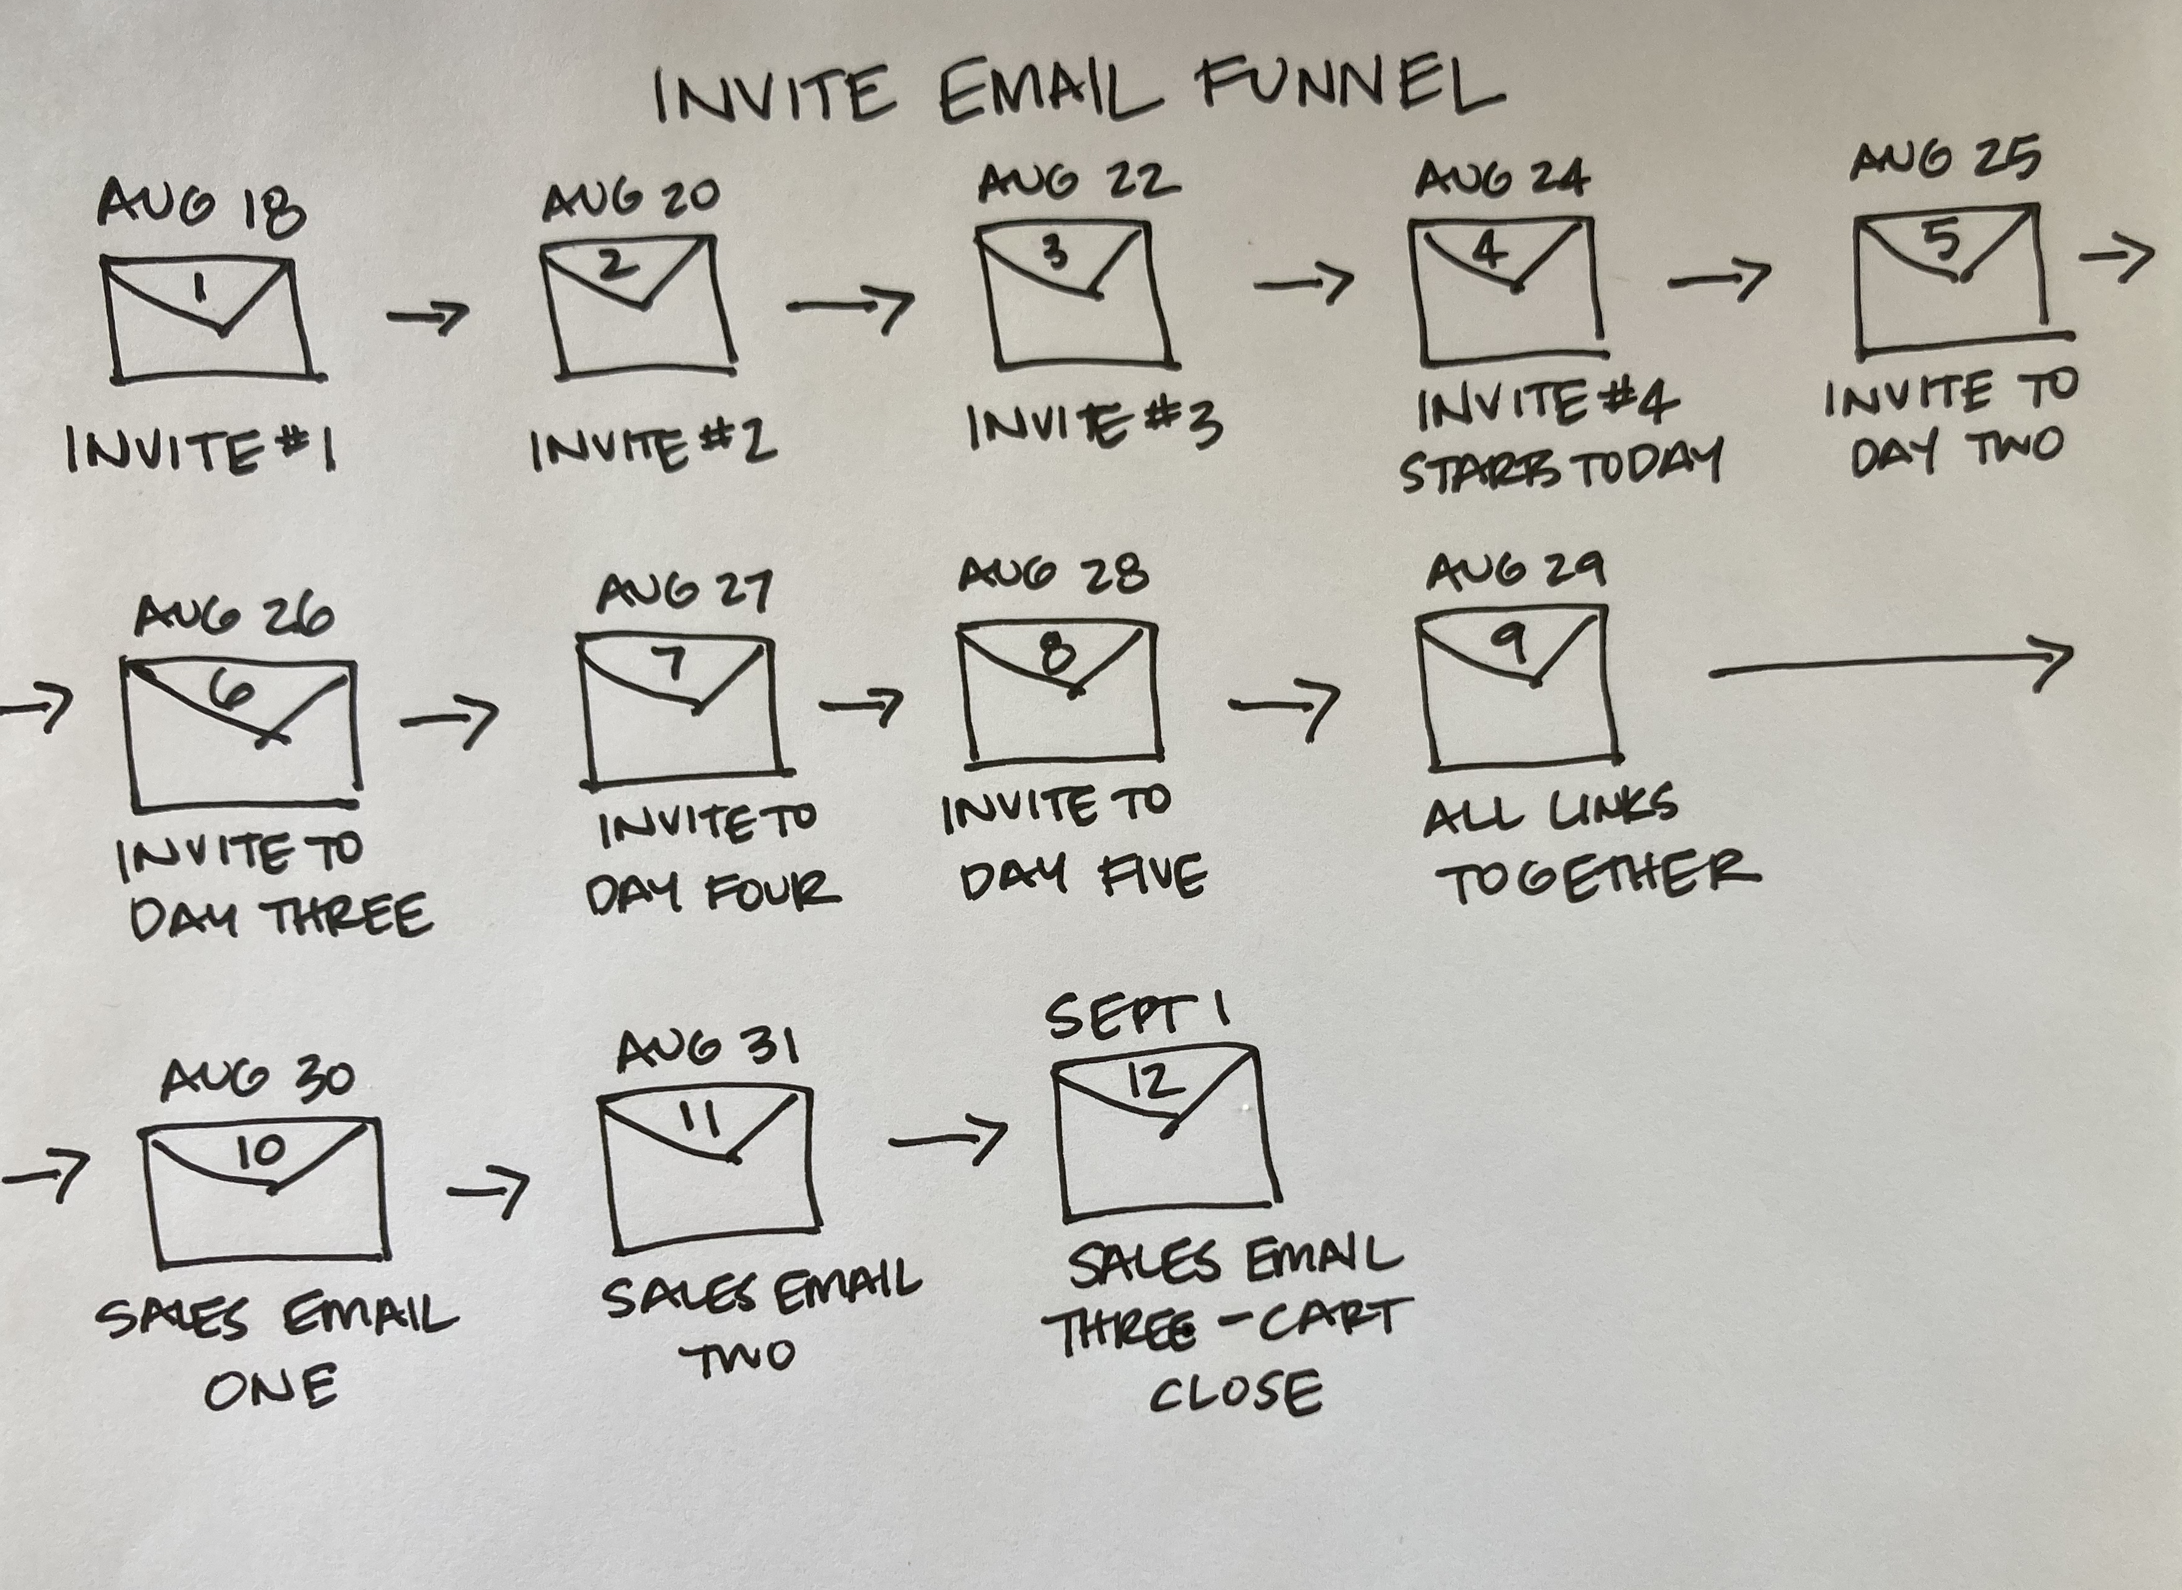

EMAIL 10 ADDED INTO YOUR INVITE EMAIL FUNNEL: SALES EMAIL 1
Notice how it’s just a slight change from the Warm-Up Funnnel Sales Email 1.

Subject: If you need hand-holding & step-by-step marketing help
Preview: ...The Marketing Mastery Academy is Now Open!
Date: Assuming you started your challenge August 24th, you would send this on August 30th

Hi ~Contact.FirstName~,

Enrollment in our Marketing Mastery Academy
Group Coaching Program is NOW OPEN!

I remember clear as day the first successful online product launch sales that I ever made. After investing $5000 in Facebook ads (gulp!) and hosting my first webinars, I opened my inbox and there was notices of money in the bank.

I thought I would cry with joy! $59,913 in bank from selling 29 programs.

That risk doubly paid off when I successfully filled my retreat 12 months later from all the new folks I added to my list from my webinars.

Now not all our clients choose to do Facebook ads, online programs and webinars, but what ALL the successful ones have done is to invest in creating their own customized marketing plan and implementing it so that becomes their go-to strategic plan for what to do each day, week, month and year.

If you’re ready for some hand-holding, step-by-step, advanced marketing training, then I invite you to join our:

Marketing Mastery Academy
6-month, In-depth, Step-by-Step, Marketing Program
Starting October 30th

BUTTON: Tell me more Sheri! [link to program sales page]

The Details:
- Our Live Interactive Implementation Coaching calls start on October 30th and run through April 22nd 2020 (you can always catch a replay).
- You'll get our over-the-top personalized feedback + coaching (which we're known for!) on our LIVE Implementation calls and in our private Facebook group for 6 months (so you can actually get your marketing DONE).
- All the skills you need are in the 8 online modules AND THEN we're there to help you apply those skills to your business during the 13 Live Implementation Coaching Calls and in the FB group. These calls are 100% coaching you, answering your questions, and working through your marketing needs.
- We’ve purposefully designed the program for our heart-centered folks who are ready to do more advanced marketing… this is a holistic, comprehensive program that walks you through how to connect all aspects of your marketing.
Not sure if this program is for you? We're happy to hop on a call with you here: http://bit.ly/MMAtalk [link to your calendar for a clairty/sales call]

BUTTON: Yes I’m ready to sign up! [link to program sales page]

If Christine could learn and implement what she needed to be able to reach more clients online - so can you!

[insert client testimonial about working with you if you have one]

We’ve made the investment as affordable as possible....
So let’s stop dreaming about running retreats and creating a business that’s ready to fill them – it’s time to actually DO the important work of getting clear on your people, problems, positioning and then move on to a marketing plan and develop the skills you need to be a marketing pro when it comes to promotion.
You know we’d love to work with YOU.

To your wanderlust life and business, Sheri, Meghan + The Wanderlust Team

PS: During the program, you’ll:
- Know exactly what focused, productive actions to take each week in your marketing
- Craft a simple marketing PLAN with the best strategies for YOU - so your efforts aren’t hodgepodge
- Break the cycle of trying the newest strategy – only to go back to doing nothing
- Re-purpose and reuse content across different social media and online platforms to save time and make the biggest impact
- Increase the speed and ease of finding new paying clients
- Revamp the out-of-date text on your website and add a fantastic freebie
- Write a perfect sales page for your programs, products, workshops or retreats
- Demystify landing pages, automated email funnels, and Facebook ad marketing
- Know how to do a Facebook Live to promote your program or retreat
- Know which list-building strategies are best for YOU – and that might be using summits, giveaways, challenges, ads, Facebook bots – whatever!
- Craft a webinar that makes sales
- Actually grow your list and social media following (for real!)
- Automate your business so it’s not a time suck
- Have expert support to run your ideas past and be accountable for implementing them

BUTTON: I need this – sign me up! [link to program sales page]

EMAIL 11 ADDED INTO YOUR INVITE EMAIL FUNNEL: SALES EMAIL 2
Notice how this is the same as the Warm-Up Funnnel Sales Email 2.

Subject: What would happen in your biz if marketing no longer stressed you out..
Preview: ..and you had a step-by-step plan for growing your business?
Date: Assuming you started your challenge August 24th, you would send this on August 31st

Hi ~Contact.FirstName~,

So many of us are on a mission right now to share our greatest gifts and support all the shifts that are happening on the planet through our retreats and offerings.

To find the folks that you are meant to serve and support, you must be marketing yourself constantly – and from where I sit, only your thoughts, emotions and actions (or lack of!) can stop you from fulfilling your vision.

Being in business forces you to think more strategically, be seen and heard, and examine your beliefs around abundance... (and the list goes on!)
And yes, it's damn scary.
But your business is constantly giving you the opportunity to step up, to empower yourself, and most importantly - your business is the next step in your spiritual evolution and personal growth.

Truly.
Because it makes you do the things that are hard...
And the things you don't like...
And the things you don't think you're capable of doing or learning.

So are we just going to sit around - or are we going to look at the challenges we're facing and take action and do something about it?

The Top 4 Marketing Challenges Retreat Leaders Face

1. You don’t actually know which specific marketing activities would work best for you, your talents and your audience, and how to pull those activities into a dependable marketing plan for your business.

2. You avoid marketing because you’ve decided you don’t like it or you don’t have the technical skills you need or the thought of it simply overwhelms you.

3. You practice “hummingbird marketing” like I did (where you flit around from one method to another and then drop it, work hard for a couple of weeks and then stop because it doesn’t seem to be working) or “in the mood marketing” like Meghan where you only market when you feel like it.

4. You struggle with self-sabotaging internal dialogue that keeps stopping you in your tracks. Thoughts and feelings like feeling defeated, frustrated, overwhelmed, nervous or disappointed.

Maybe you’ve been thinking or feeling the same way?
So as my mentor don Miguel Ruiz, author of The Four Agreements, taught Meghan and me – you have a choice.

You can keep having the same thoughts and emotions and taking the same actions (or lack of!) or you can choose to educate yourself, get support, implement and follow through - which is the key to success.

We’ve poured everything we’ve learned to create our 7-figure business, everything you need, and everything we use with our private clients into:

Marketing Mastery Academy
6-month Hands-on Group Coaching Marketing Program
with LIVE Implementation Classes
October 30th to April 22nd

BUTTON: I’m curious – tell me more! [link to program sales page]

Imagine how great it would be to work with FABULOUS PAYING CLIENTS, tap into your CONFIDENCE to get "out there" and reach a BIGGER audience around the world, and have the EXACT TOOLS and TEMPLATES to market and grow your business.

Not sure if this is for you? Hop on a call with Sheri or Meghan here: http://bit.ly/MMAtalk [insert link to schedule a clarity/sales call on your calendar]

So don’t keep struggling alone.

You can join us on our 13 LIVE IMPLEMENTATION Coaching calls or catch the replays – and you’ll have FOREVER access to the online resources, worksheets and templates that walk you through step-by-BABY-step on everything you need.

PLUS, there are six solid months of support, hand-holding, answering your questions, and LIVE coaching in our private Facebook group.
We also have some fantastic bonuses for you too!

Hear the fear. Then take action anyway.

Let’s solve the issues that are holding you back in your marketing - together. If you're not sure if this program is right for you email me back and we can hop on a call together.

To your wanderlust life and business, Sheri, Meghan + The Wanderlust Team
P.S. There are people out there that NEED your help. You have solutions that they could use. How much longer are you going to deprive the world of your mad gifts and talents?
P.P.S. If you have a friend, client or colleague who could use this support, would you do me – and the world a favor by passing this on?

BUTTON: Get ALL the details here! [link to program sales page]

EMAIL 12 ADDED INTO YOUR INVITE EMAIL FUNNEL: SALES EMAIL 3
Notice how this is the same as the Warm-Up Funnnel Sales Email 3.

Subject: This is the cure for your ailing marketing skills!
Preview: … register NOW for Marketing Master Academy!
Date: Assuming you started your challenge August 24th, you would send this on Septermber 1st

Hi ~Contact.FirstName~,

Does your head spin over writing awesome copy, figuring out your branding, designing email funnels, creating webinars, doing Facebook ads and making sales?
Not sure which daunting marketing projects you should tackle that will REALLY get you closer to filling your retreats and programs?
If you're ready to say YES to having your marketing feel easy and intuitive... and say YES to receiving the hard-core marketing know-how you need…
Then I want you to seriously consider (or better yet register for):

Marketing Mastery Academy
6-month Hands-on Group Coaching Marketing Program
+ LIVE Implementation Classes
October 30th to April 22nd

BUTTON: Register here! [link to program sales page]

In the Marketing Mastery Academy you'll learn:
- Marketing Basics: all the items you need to have in place technology-wise to uplevel your business.
- Monetizing: how to properly monetize your business and create the journey your clients are taking within your business.
- Mindset: how to not lose momentum in your business when it gets tough and how to change your relationship with money.

- Funnels: how to write welcome funnels, sales funnels, retreat funnels, program, and product funnels.
- Landing Pages: how to design landing pages and opt-in boxes for your freebie, giveaways, and more.
- Webinars: how to write and reverse engineer a webinar that sells products, programs, retreats, and events.
- Sales Pages: how to write sales pages for products, programs, live events, workshops, retreats.
- Copywriting: basic skills for writing great copy for your sales pages, freebies, webinars, and funnels.
- Selling: how to do intuitive selling that uses education based marketing in your written marketing and on actual sales calls.
- Facebook Ads Basics: how to get your first ads up and running.
PLUS: you'll get clear on who you are working with and how, your basic marketing strategy for your business, branding basics, which marketing channels to pick for what you are offering, and so much more!

Not sure if this program is for you? No worries we are happy to chat with you here: http://bit.ly/MMAtalk [insert a link to your calendar for a clarity/sales call]

It's first-aid kit for your ailing marketing skills! :)

BUTTON: I want more info! [link to program sales page]

[if you have a testimonial you can insert it here]

How is the program delivered?
FIRST: 8 online modules with training videos, scripts, templates and forms that you have forever access to where you learn the course material.

SECOND: 13 LIVE group coaching IMPLEMENTATION calls that take place over a period of 6 months with classes beginning October 30th. This is where you implement everything you learn!

(Just imagine coming onto the calls every other week and being able to share your successes and challenges with other like-minded entrepreneurs who are tackling the same skills and issues that you are. You no longer have to do this alone.)

THIRD: A 6 month membership to our private Facebook Mastermind Group to post your marketing plan, program ideas, website pages, marketing materials, and more for us to coach you on!
We invite you to join an incredible group of women and men who are ready to support each other AND implement a hell of a lot of marketing in their businesses.
We are here 100% to help you, guide you, encourage you, and support you.....just take our hand....
To your wanderlust life, Sheri, Meghan + The Wanderlust Team

PS: Classes start October 30th so do register now => JOIN THE PROGRAM HERE. [insert your program sales page link]

The clock is ticking - registration ends tonight....

EXTRA EMAIL 13 ADDED INTO YOUR INVITE EMAIL FUNNEL: SALES EMAIL 4
Notice how this is the same as the Extra Email 13 in the Warm-Up Funnnel Sales Email 4.

If you didn’t get as many sales as you wanted and are willing to go the extra mile, you can add in one more email the day before your class is set to start. We often get folks who wanted to join but forgot and this gets them to enroll!

Subject: ~Contact.FirstName~ the Marketing Mastery Academy starts TOMORROW. Joining us??
Date: You would send this the day before your first class

Hi ~Contact.FirstName~,

We are herding all our strays into our Marketing Mastery Academy Program which starts TOMORROW - Weds October 30th!

Did you have a "whoops – I meant to join and forgot" moment?

We saw that you hadn't registered - and we wanted to just check in and see if you were running late in signing up - or if you needed help with anything.

Did you need to have a conversation with Sheri or Meghan to see if this program was right for you? If so here's their calendar: http://bit.ly/MMAtalk [insert the link to your calendar for a clarity/sales call]

So if you're ready to:
- Have the freedom to travel, not be tied to one location and take folks on stand-out retreats…
- FINALLY make GOOD money…
- While still LOVING what you do (and not pulling your hair out over online marketing!)
Then join us for 6 solid months of support and accountability so you can actually IMPLEMENT your marketing with all the templates, scripts and examples that make it easy and our team cheering you on and helping you step-by-step.

BUTTON: I want more info! [link to program sales page]

You’ll be receiving:
- Personalized in-depth reviews of your marketing plan and promotional materials
- Lessons and help with your copywriting so you can create deeply compelling text
- Feedback and guidance on your income plan and selling skills
- Easy, reusable, dependable system for growing your list and audience so you can fill your retreats and build your business
- Bi-weekly coaching implementation calls so you can ask your questions and receive the cheerleading, advice and support you need
Yes, you do need to invest your time right now - but heck - after that you are going to be full speed ahead in building a business that makes your heart sing and can support retreats and isn't that worth it?

BUTTON: I’m ready to get started! [link to program sales page]

Join us now since class begins tomorrow.
To your wanderlust life and business, Sheri, Meghan + The Wanderlust Team

PS: LIVE INTERACTIVE classes start TOMORROW October 30th and run through April 22nd alternating between 12noon and 7pm New York Time!

You can join us on our LIVE implementation classes or catch the replays.

You’ll have FOREVER access to the online classes and worksheets that walk you through step-by-BABY step on everything you need.

You also get six month’s access to our private course Facebook group, where you can share ah-ha’s, homework, resources, ideas, and revelations — AND get answers from us.

NOW YOUR TURN:

STEP 1: Using the Sales Email Template as your example, you’ll now write out your own email funnels.

Don’t get fancy – just use our template and replace your info with ours!

HOT TIPS: Get your Warm – Up & Invite Funnels done first. You can be writnig these even during your challenge week! Take them step-by-step.

Remember you can use the wording you came up with on for your online program, challenge/webinar pain points and benefits and the advertising bullet points in the email funnels.

We find it’s helpful to bullet point the main topics you’ll cover within each email. You might want to start by scribbling out your sequence on a whiteboard or piece of paper and organizing all your ideas together.

STEP 2: After you receive our thumbs up, you need to upload your emails into your autoresponder.
If you have any questions, please let us know!

