Welcome & Warm Up Challenge Email Funnel Template

Before you tackle writing this email funnel, we HIGHLY recommend you read through the What is an Email Funnel? Instructions & Prep: https://howtocreatearetreat.s3.amazonaws.com/marketing-mastery/WhatisEmailFunnelMMA.docx

This funnel is using August 24th as an example for the first day of your 5-day challenge. If you are using a different date, simply adjust the days and spread out the emails as needed.
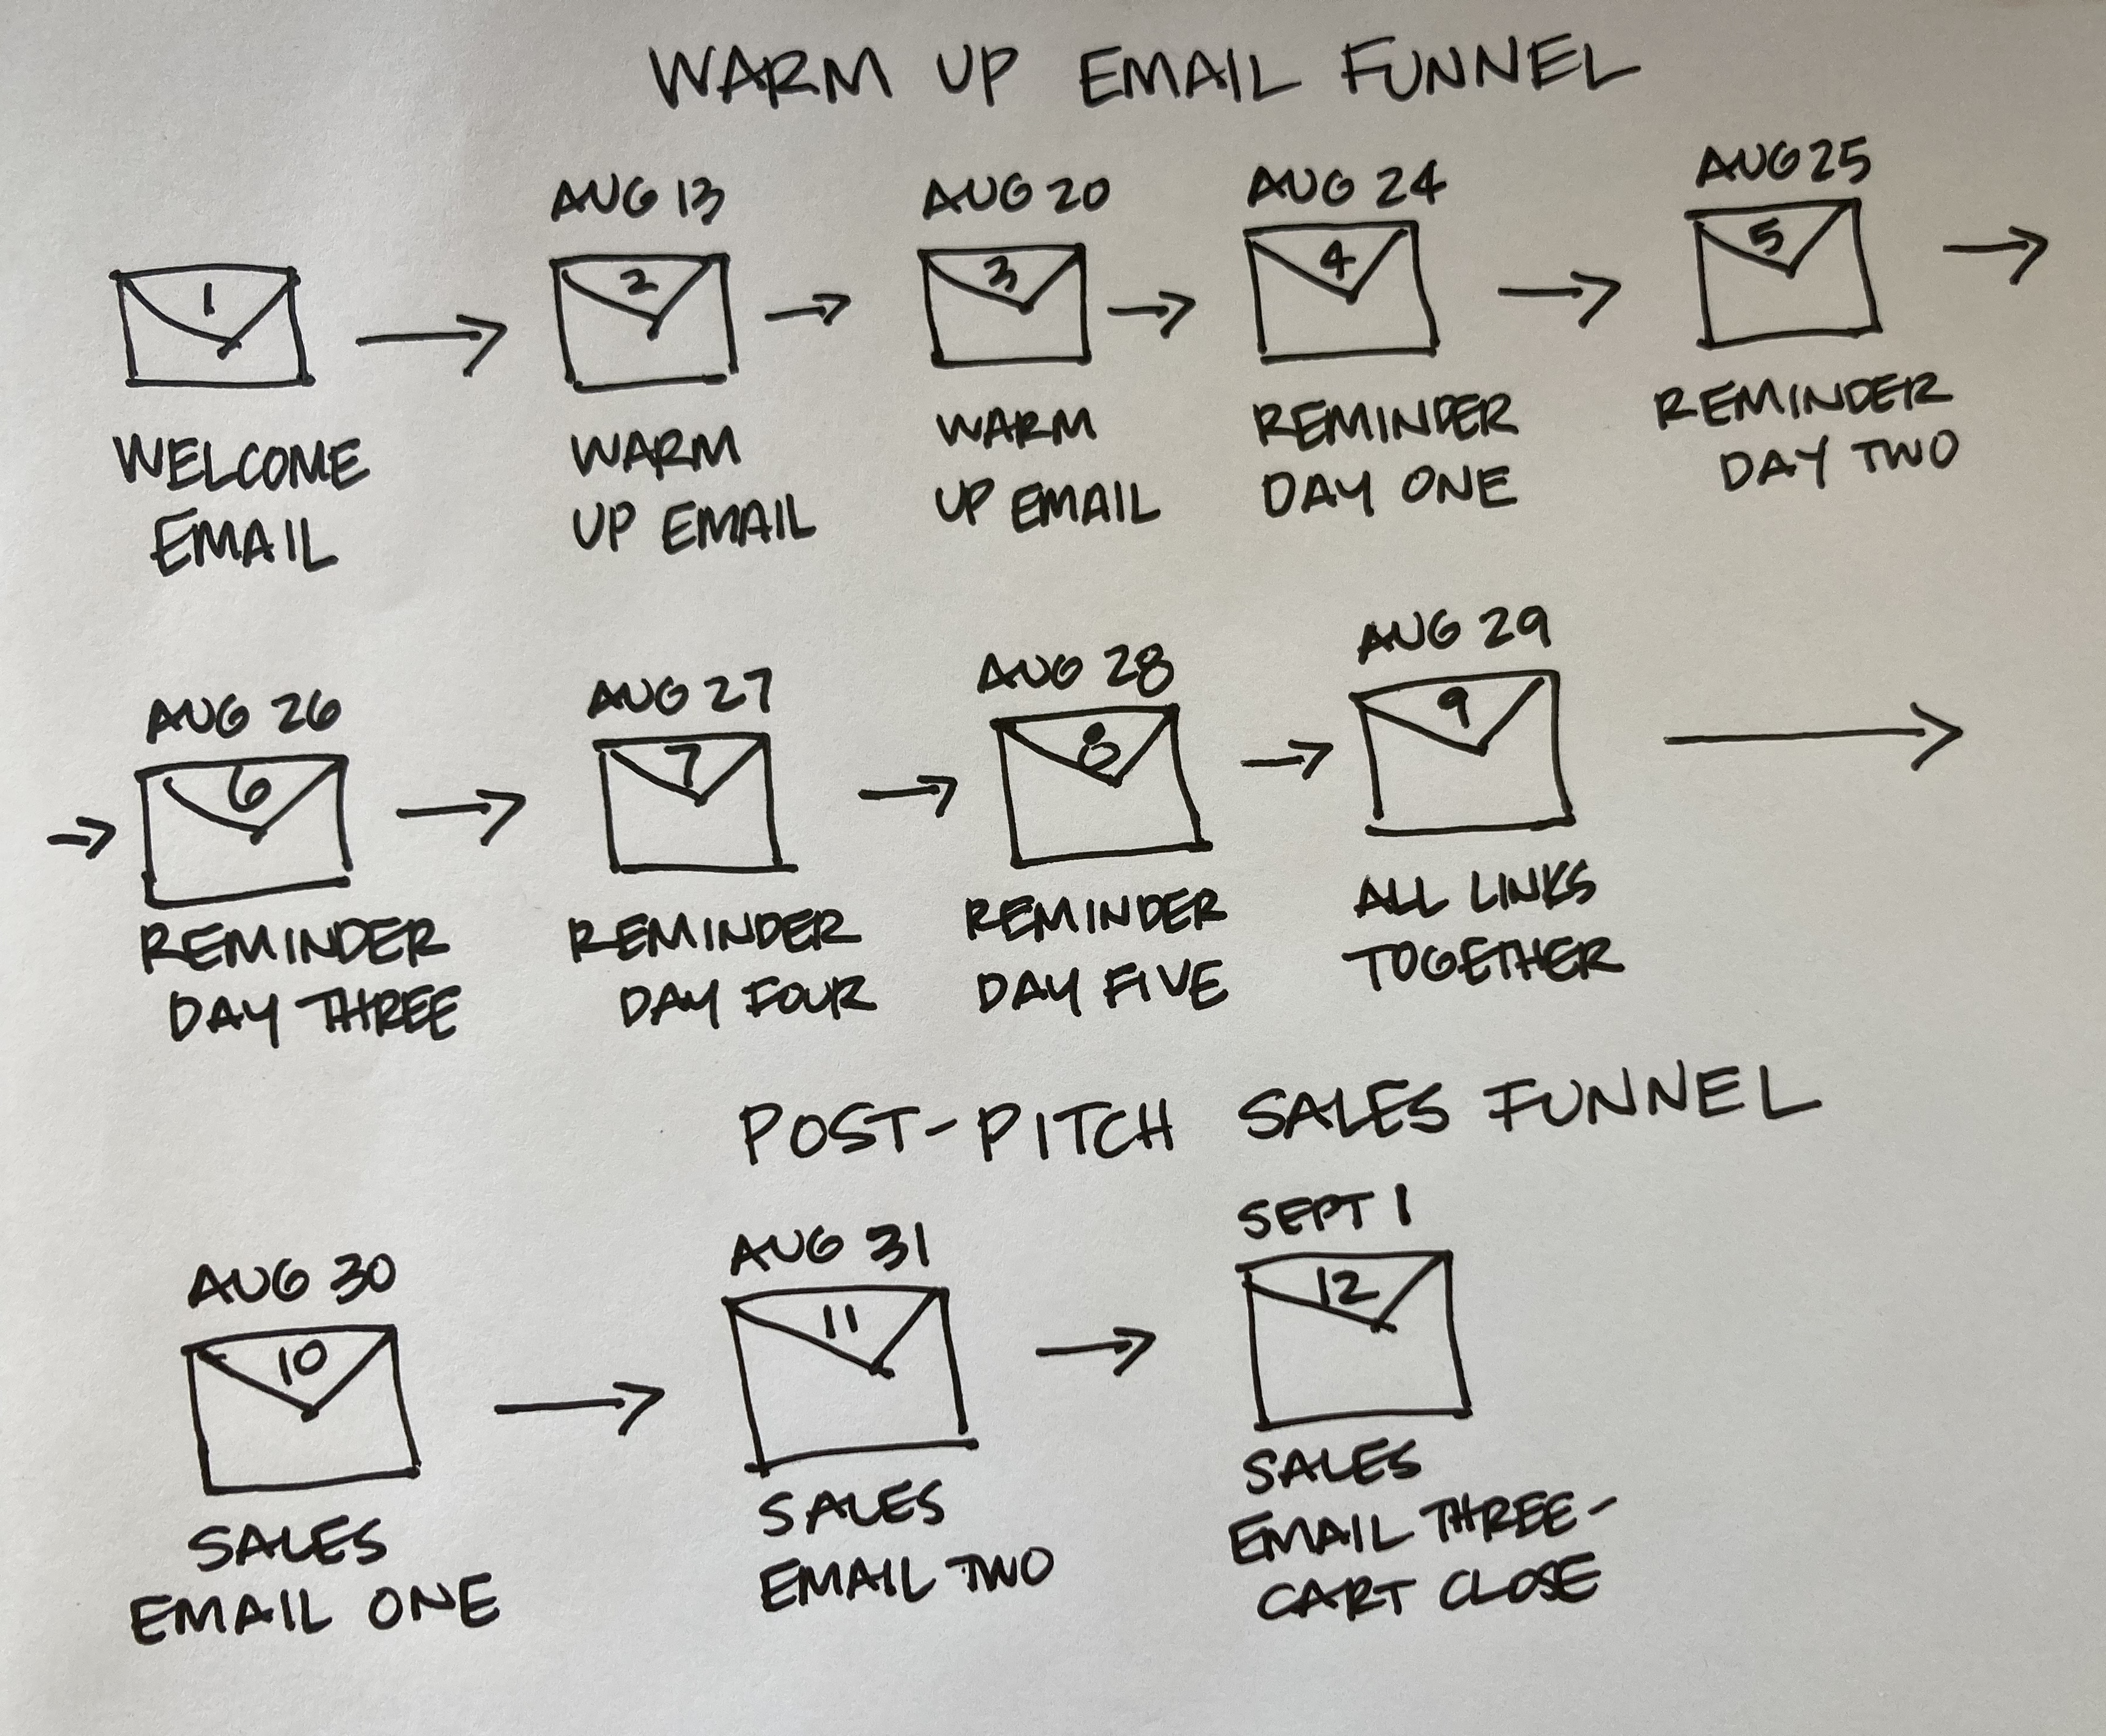

As a reminder:
Welcome Email
Once someone goes to your landing page and they register for your challenge, webinar or event, they get redirected to your thank you page AND the first email they receive is
your welcome email – it’s critical to get this up and running even if you don’t have the rest of your email funnels else in place!

Warm-Up Email Funnel (also called your Challenge Delivery or Content Delivery Funnel)
For everyone, you then need to work on the emails you are sending out to anyone who registers for your challenge (or webinar or 3-day event or retreat) to keep them engaged from the time they sign up to until you actually do your challenge (or webinar or 3 day event or retreat), then remind them to attend each day.

We’ll be sharing the post-pitch sales email funnel in a separate template – these go at the end of your warm-up email funnel and share the details of your online program. These sales emails do NOT need to be in place to set up your warm-up email funnel. You can add these in later on, step-by–step.

Remember – folks are going to be coming into your warm up email in two ways. If you have a list and invite them, they can sign up on your landing page and then they’ll get the welcome email and warm up email funnel.

The second way is coming in through social media, which is going to be the primary method if you do not have a list.

Remember when you are writing an email funnel you want to:
- Address your clients’ pain points and how that relates to your promise and benefits
- Overcome any objections your client may have around coming to your challenge or buying into the idea of your promise in general
- Write in conversational everyday language like you are speaking to your best friend over coffee. Do not use practitioner speak!
- Mix up the type, length and style of your emails. Notice how we re-use some info without making it seem like it’s exactly the same.
- Add a tantalizing subject line for each email
- Don’t forget to add a fun royalty free photo in your emails!

We have given you examples of each email below and instructions at the end of this document. Don’t get fancy – just use our template and replace your info with ours! Do make sure you have changed out the dates to match your challenge.
Welcome Email
After you set up your challenge landing page and thank you page, you need to connect it to your welcome email - which is the first email in your warm-up funnel. In this email, you are going to give your participants the basic information and confirming that they are registered for your challenge (or webinar or 3-day event or retreat.)

Subject: Whoot!! You're in for our “Grow Your Biz, Fill Your Retreats" Challenge!
Date: This gets automatically triggered in your autoresponder when a participant registers for your challenge.

Hi ~Contact.FirstName~,

Congratulations! So excited you’re joining us!

Here’s exactly what’s going to happen in our "“Grow Your Biz, Fill Your Retreats" 5 Day Challenge"…..

Each day of the challenge WE ARE going to:
Host a fabulous and fun Challenge Facebook Live where you’ll learn a key step to help get you clearer on what you need to do to UPLEVEL your marketing so you can get your programs and retreats FILLED.

And each day of the challenge YOU ARE going to:

Post your answer our daily question in our Facebook Group where we can celebrate your progress! => [insert button]

[insert the prize info only if you are doing a giveaway]
Each day that you post in the FB group qualifies you for our Daily Challenge Contest!

Yup, we’ll be giving away fun prizes. Whoot!

Now what?
Download our Grow Your Business, Fill Your Retreats Challenge Guide! You’ll be using this to follow along each day of the challenge.

Download Free Challenge Guide!
[insert link to challenge guide – if you do not have this ready yet, then DELETE this line from this email and from your landing page and make sure you include the link in your reminder emails]

To your wanderlust life, Sheri, Meghan & The Wanderlust Team xo

PS: Day One of the Challenge begins October 7th - so make sure you watch the first Livestream at INSERT TIME then!

Warm Up Email Funnel
This warm up email funnel starts with your welcome email. You then add in some “warm up” emails to get your participants excited about your challenge, educating them on their pain points. This keeps them engaged between the time they register and the actual start of the challenge.

Then you want to send them reminder emails every day of the challenge and an “all the videos here” email after the last day. Finally, you’ll add in your sales emails at the end of this email funnel – which we’ll share in a separate doc.

EMAIL 1: Your Welcome Email (see above)

EMAIL 2: WARM UP EMAIL (also called an Engagement Email)
SUBJECT: Are you struggling to get folks to register for your Retreats and offerings?
PREVIEW: ...this is probably why...
Date: Assuming you are doing your challenge starting August 24th, you would send this on August 13th.

Hi ~Contact.FirstName~,
(Sigh…) Ever feel like NO ONE is signing up for your retreats and other offerings? Or not as many folks as you were dreaming of? :(
Frustrated that your email list and social media following isn’t growing as fast as it should?
It makes us bonkers that so many of the crazy-talented folks in our retreat community aren’t attracting their favorite clients and making the income they deserve.

After looking at thousands of our client’s businesses, we know that all these problems can be solved with ONE tweak: the right marketing.

Now most entrepreneurs have a pre-conceived idea of what “marketing” means, but we like to break it down into minding your P’s.

Effective marketing means you know your:
- PEOPLE (understanding WHO your ideal client is psychographically)
- PROBLEMS (WHICH concrete problems can you solve for them)
- POSITIONING (WHAT unique solutions to offer through your unique products & services)
- PLANNING (WHERE to focus your marketing strategy and actions consistently & confidently)
- PROMOTION (HOW to find these potential clients and turn them into buyers)
Most entrepreneurs skim over the first 4 critical steps - the PEOPLE, PROBLEMS, POSITIONING, and PLANNING and they want to jump directly into PROMOTION and this is a huge mistake.
That’s why I’m so happy that you registered for our powerful Grow Your Business, Fill Your Retreats Challenge 5 Day Challenge on INSERT DATES for our retreat leaders, travel professionals, and meeting planners. You are going to learn how to become a savvy retreat marketer!

Here’s what you’ll walk away with:
- The Top Four Critical Marketing Issues That are Stopping YOUR Success (and how to nip them in the bud!)
- The Five Marketing Steps You MUST Take to Make the Income You Deserve (most entrepreneurs skip these with disastrous results)
- Our Behind the Scenes FINANCIALS (how we built our business – Sheri reveals all…)
- What it HONESTLY Takes to Craft a Business That Makes $100,000+ a Year (here are the numbers!)
- How to Actually WANT to (and enjoy) Marketing Consistently + Confidently (imagine that!!)

PLUS! What most free challenges won’t admit or tell you…

We'll make sure that by the end of this challenge you know what needs to be in place to have the RIGHT clients racing to sign up for your retreats and other programs.

Can’t wait to see you on the Facebook Livestreams!
To your wanderlust life + business, Sheri, Meghan + The Wanderlust Team
PS. We're only offering this LIVE challenge ONCE this year. If you know someone who could benefit from this challenge, would you please pass this email on? They can REGISTER HERE. (insert link to landing page)

EMAIL 3: WARM UP EMAIL
Subject: You've got to stop gnashing your teeth over marketing
Preview: ...it does not have to be confusing, overwhelming, dreadful, or fake
Date: Assuming you are doing your challenge starting August 24th, you would send this on August 20th^{th}.

Hi ~Contact.FirstName~,

How do YOU feel about marketing? I want the honest TRUTH!
What I most often hear from our heart-led entrepreneurs is that it’s “confusing, overwhelming, annoying, dreadful, fake, frustrating, time-consuming, boring, stressful…”
And truly, I can SO relate.

After I sold my medical practice and started studying with don Miguel Ruiz (author of the The Four Agreements), I started teaching locally only to realize that I’d NEVER make the income I wanted or reach the number of people I dreamed of serving if I didn’t get savvy on how to market myself online globally.
I’ve gnashed my teeth over figuring out Facebook ads, Autoresponders, Email Funnels, Branding, Niche, Conversions, Webinars, Copywriting…. And all the technology!
That part actually turned my hair grey. LOL. :)

After taking countless programs and working with many top name coaches, I finally got strategic and focused my attention on just a couple of methods that highlighted MY unique talents and strengths and that made ALL the difference (rather than focusing on the newest, hottest marketing strategy).

My list grew to over 70k in 3 years and I hit the 7-figure mark. I started spending 6-figures on Facebook ads. (Yes, you did read that correctly.) And I now have a team of 8 awesome angels working for me.

Whether or not you want a business that big, I want to encourage you come to the 5 Day challenge where I'll be sharing my ACTUAL income numbers from my business.

(And yes, this is quite interesting!)

To get you excited, here’s what you will you walk away with by the end of our Grow Your Business, Fill Your Retreats Challenge 5 days together (thanks for already registering!):
- Exactly what needs to be done to grow your list consistently so you can fill your workshops, retreats, and programs
- Know exactly what’s missing or not working in your current marketing
- Clear promotional actions you must take BEFORE you waste more time or money
- An income blueprint for making $100,000+ from anywhere in the world, no matter what your niche is
- A new mindset and enthusiasm for marketing (so you can get FINALLY consistent and confident)
Since I know marketing may NOT make you want to do backflips (yet), I’m going to recommend that you participate in all 5 days.

=> To inspire you to come, I’ll be giving away a very special gift: "Grow Your Business, Fill Your Retreats Guide" so you make the most out of the challenge. If you haven’t downloaded it yet, make [insert link] sure you have it handy for day one! <=

Let’s change your attitude about marketing AND get you the skills that will make a serious difference in your business.

To your wanderlust life + business, Sheri, Meghan + The Wanderlust Team
P.S. Give me 15-20 minutes of your time each day and I promise you’ll walk away with tips that you can implement IMMEDIATELY that will bring in new clients. And yes, we'll have a replay for each Facebook Live in case you want to attend, but can't make the times offered.

EMAIL 4: CHALLENGE DAY 1 REMINDER EMAIL
Subject: [DAY 1 CHALLENGE] Your Ideal Client – Psychographics vs. Demographics
Preview: Knowing the difference makes sales
Date: Assuming you are doing your challenge starting August 24th, you would send this on August 24th.

Hi ~Contact.FirstName~,

Whoot!

It’s DAY ONE of our “Grow Your Biz, Fill Your Retreats Challenge” and today we’re going to be talking about YOUR IDEAL CLIENT – the person who you'd LOVE to work with and will gladly pay you to go on a retreat plus buy your other offerings all year long.
To attract the right clients, you must understand them body, mind and soul – otherwise it’s going to be hard to grow your list!
But how do you do that??

Here’s what WE'RE going to cover in today’s Challenge:
- First we're going to talk about psychographics vs. demographics. Why? Because you cannot attract your ideal clients without being 100% clear on their psychographics. And if you don't know what that is - that's probably why your marketing is suffering.
- How to attract the clients you want instead of the mishmash of various people you might currently be attracting who are NOT necessarily your perfect clients.
- What you MUST do to make a truly heartfelt connection with your ideal client.

And here’s what YOU'RE going to do today:
- Watch our DAY ONE Challenge Facebook Live at INSERT DAY & TIME! (You can always watch it on replay if you can’t make that time.)

Take me to Facebook Group now! [insert link to FB Group]

- Then post your answer to the Challenge Question in the Facebook Group.

Haven’t downloaded our Grow your Business, Fill Your Retreats Challenge Guide yet? You’ll be using this to follow along each day of the challenge.

Download Free Challenge Guide! [insert link to challenge guide]

To your wanderlust life, Sheri, Meghan & The Wanderlust Team xo

EMAIL 5: CHALLENGE DAY 2 REMINDER EMAIL

Subject: [DAY 2 CHALLENGE] Your Ideal Client – Their Top-of-Mind Issues & Pain Points
Date: Assuming you are doing your challenge starting August 24th, you would send this on August 25th.

Hi ~Contact.FirstName~,

Wow! It’s DAY TWO of our “Grow Your Biz, Fill Your Retreats Challenge” and today we’re going to dive into PROBLEMS - and what are the exact top-of-mind concerns you solve for your ideal clients?

Not just any old problems - but the VERY specific problems, issues and/or pain points that would drive them to want to work with YOU and come on your retreats.
Can't think of anything concrete?
Then don't miss today - because solutions are what builds VALUE in your business and it's what people will pay for.

Here’s what WE'RE going to cover in today’s Challenge:
- How to get clear on EXACTLY what problems you solve in your business and on your retreats so you can highlight this on both your retreat sales page and on your business website.
- Why psychographics (remember we talked about this yesterday) are critical for helping you determine your clients top-of-mind issues and pain points.
- Why people don't care WHAT method you are going to use to help them (so stop focusing on your modalities).

And here’s what YOU'RE going to do today:

- Watch our DAY TWO Challenge Facebook Live at INSERT DAY & TIME! (You can always watch it on replay if you can’t make that time.)

Take me to Facebook Group now! [insert link to FB Group]

- Then post your answer to the DAY TWO Challenge Question in the Facebook Group.

Haven’t downloaded our Grow your Business, Fill Your Retreats Challenge Guide yet? You’ll be using this to follow along each day of the challenge.

Download Free Challenge Guide! [insert link to challenge guide]

To your wanderlust life, Sheri, Meghan & The Wanderlust Team xo

PS: Did you miss the FIRST challenge?
No worries at all…. To watch the first training on YOUR IDEAL CLIENT – the person who you'd LOVE to work with and will gladly pay you to go on a retreat plus buy your other offerings all year long CLICK HERE. [link to Facebook Livestream post url]

PPS: We’re loving all the Challenge comments and the posts and more importantly, the creative expression of our community which is awe inspiring! :)

EMAIL 6: CHALLENGE DAY 3 EMAIL REMINDER
Subject: [DAY 3 CHALLENGE ] Positioning Your Programs to Solve Your Ideal Client’s Problems
Preview: So you can fill your retreats & programs
Date: Assuming you are doing your challenge starting August 24th, you would send this on August 26th.

Hi ~Contact.FirstName~,
The amount of experience, heart, desire to change lives, and give back to the world is staggering in our community. Truly impressive!

Now it's time to make sure that the whole planet knows about your business and your retreats (or at least as many peeps as YOU want to reach)!

That's why on DAY THREE of our “Grow Your Biz, Fill Your Retreats Challenge” we’re going to focus on POSITIONING - and what solutions you offer to help solve your ideal clients’ problems and concerns.

Because when you position your products to solve your client’s problems – that’s what makes them sell so you can make the money you deserve.

Here’s what WE'RE going to cover in today’s Challenge:
- Why if you offer products, programs, and retreats that SOLVE your clients issues you don't have to be salesy. They'll naturally WANT what you are sharing.
- Why you MUST switch from practitioner-centric to CLIENT-CENTRIC marketing.
- Why you've got to stop creating offerings around topics YOU want to teach or share - and instead focus on designing offerings that specifically solve your CLIENT’S top issues.

And here’s what YOU'RE going to do today:

Watch our DAY THREE Challenge Facebook Live at INSERT DAY & TIME!
(You can always watch it on replay if you can’t make that time.)

Take me to Facebook Group now! [insert link to FB Group]

- Then post your answer to the DAY 3 Challenge Question in the Facebook Group.

To your wanderlust life, Sheri, Meghan & The Wanderlust Team xo

PS: Did you miss the FIRST TWO challenges?
No worries, you can EASILY catch up….
[insert links to the FB Livestream Replay urls]
CLICK HERE to grab the first challenge training on YOUR IDEAL CLIENT – the person who you'd LOVE to work with and will gladly pay you to go on a retreat plus buy your other offerings all year long.

CLICK HERE to watch the second challenge training on PROBLEMS - and what are the exact top-of-mind concerns you solve for your ideal clients?

EMAIL 7: CHALLENGE DAY 4 REMINDER EMAIL
Subject: [DAY 4 CHALLENGE ] Creating a Plan to Attract Your Ideal Clients
Preview: For retreats and all your other offerings
Date: Assuming you are doing your challenge starting August 24th, you would send this on August 27^{h}.

Hi ~Contact.FirstName~,
Let's be straight-up - you want to make a difference in your clients' lives AND you want to make good money, right?

Can I get an amen here?!?

Well that's why during DAY FOUR of our “Grow Your Biz, Fill Your Retreats Challenge,” we’re going to have a blast discussing PLANNING - and how you're getting yourself “out there” so that your ideal clients can easily find you and start following you.

It’s time to focus on and attract your tribe, build your list and keep them interested so they get to know, like and trust you enough to come on a retreat!

Here’s what WE'RE going to cover in today’s Challenge:
- Why constantly growing your list and social media following is one of the most CRITICAL actions you can possibly take in your business! Without these actions it's going to be very hard to keep filling your retreats and programs.
- Why you must CONSCIOUSLY design the step-by-step journey you’re taking your clients on from the second they meet you to when they finally purchase from you.
- What is your business ASCENSION model – what it is and why you need one?

And here’s what YOU'RE going to do today:

1. Watch our DAY FOUR Challenge Facebook Live at INSERT DAY & TIME!
(You can always watch it on replay if you can’t make that time.)

Take me to Facebook Group now! [insert link to FB Group]

- Then post your answer to the DAY FOUR Challenge Question in the Facebook Group.

To your wanderlust life, Sheri, Meghan & The Wanderlust Team xo

[insert FB Livestream urls]

PS: Need to catch up?
The challenge is picking up steam, realizations are coming left and right, and everyone is having an amazing time! If you missed the FIRST THREE challenges, no worries, you can EASILY catch up….

CLICK HERE to grab the first challenge training on YOUR IDEAL CLIENT – the person who you'd LOVE to work with and will gladly pay you to go on a retreat plus buy your other offerings all year long.

CLICK HERE to watch the second challenge training on PROBLEMS - and what are the exact top-of-mind issues you solve for your ideal clients?

CLICK HERE to catch the third challenge on POSITIONING - and what solutions you offer to help solve your ideal clients’ problems and concerns.

EMAIL 8: CHALLENGE DAY 5 REMINDER EMAIL
Subject: [DAY 5 CHALLENGE] Creating a Yearlong Promotional Strategy for Sales
Preview: One that you'll enjoy and do consistently...
Date: Assuming you are doing your challenge starting August 24th, you would send this on August 28th.

Hi ~Contact.FirstName~,

OMG it's the LAST day of the challenge and we're thrilled at how much fun we're having with our community - plus the level of ah-ha's and realizations in the group!
Make sure you take time to post in the Facebook group and let us know what you've learned.
For DAY FIVE of our “Grow Your Biz, Fill Your Retreats Challenge,” we’re going to be discussing PROMOTION - and how you're getting your offerings out there so that your potential clients can purchase what you're sharing.

Here’s what WE'RE going to cover in today’s Challenge:
- Why you must have 2-3 specific promotional strategies and actions that you do regularly and confidently all year long.
- How you can stop doing “hummingbird marketing” and “when you feel like it” marketing and hold yourself responsible for continually growing your list and business.
- Why you need to set up a promotional calendar in your business so that you're not all over the place with your promoting. (Otherwise your marketing will be inconsistent and you'll keep losing traction in your business.)

And here’s what YOU'RE going to do today:
- Watch our DAY FIVE Challenge Facebook Live at INSERT DAY & TIME!
(You can always watch it on replay if you can’t make that time.)

Take me to Facebook Group now! [insert link to FB Group]

- Then post your answer to the DAY FIVE Challenge Question in the Facebook Group.

To your wanderlust life, Sheri, Meghan & The Wanderlust Team xo
[insert FB Livestream urls]

PS: If you missed the FIRST FOUR challenges, no worries, you can EASILY catch up….
CLICK HERE to grab the first challenge training on YOUR IDEAL CLIENT – the person who you'd LOVE to work with and will gladly pay you to go on a retreat plus buy your other offerings all year long.
CLICK HERE to watch the second challenge training on PROBLEMS - and what are the exact top-of-mind issues you solve for your ideal clients?
CLICK HERE to catch the third challenge on POSITIONING - and what solutions you offer to help solve your ideal clients’ problems and concerns.
CLICK HERE to dig into the fourth challenge on PLANNING - and how you're getting yourself “out there” so that your ideal clients can easily find you and start following you.

EMAIL 9: ALL YOUR LINKS TOGETHER EMAIL
Subject: ALL your Retreat Challenge links in ONE Place PLUS what's next!
Date: Assuming you are doing your challenge starting August 24th, you would send this on August 29th.

Hi ~Contact.FirstName~,

Want to learn more??
Of course you do! I hope we're not done - yet!

I HIGHLY recommend you join me for our Marketing Mastery Academy!

Here's why............
This online program is going to tie together everything you've learned so far in the challenge, and how it relates to your retreat marketing.
Now that you have the 5 P's of marketing from the challenge - we'll dive into how YOU can build the perfect strategy to fill your retreats and programs ALL YEAR LONG.

So DO NOT miss this.

Find out more about Marketing Mastery Academy Here! [insert button with sales page link]

To your wanderlust life & biz, Sheri, Meghan & the Wanderlust Team

PS: If you missed a day - here are the links to the 5 Day Challenge:
[insert Facebook Livestream urls]
**The replays will be available until October 21st at midnight Los Angeles time!**

CLICK HERE to grab the first challenge training on YOUR IDEAL CLIENT – the person who you'd LOVE to work with and will gladly pay you to go on a retreat plus buy your other offerings all year long.
CLICK HERE to watch the second challenge training on PROBLEMS - and what are the exact top-of-mind issues you solve for your ideal clients?
CLICK HERE to catch the third challenge on POSITIONING - and what solutions you offer to help solve your ideal clients’ problems and concerns.
CLICK HERE to dig into the fourth challenge on PLANNING - and how you're getting yourself “out there” so that your ideal clients can easily find you and start following you.
CLICK HERE to dive into the fifth challenge on PROMOTION - and how you're getting your offerings out there so that your potential clients can purchase what you are sharing.

NOTE: You will add in your Post-Pitch Sales Emails for CHALLENGE PARTICIPANTS to this funnel. We’ll be sharing a template for you later in the program.

NOW YOUR TURN:

STEP 1: Using the Warm Up Email Template as your example, you’ll now write out your own email funnels.

Don’t get fancy – just use our template and replace your info with ours!

HOT TIPS: Get your Welcome Email set up first. Then you can add in your Warm-Up emails. Take them step-by-step.

Remember you can use the wording you came up with on for your online program, challenge/webinar pain points and benefits and the advertising bullet points in the email funnels.

We find it’s helpful to bullet point the main topics you’ll cover within each email. You might want to start by scribbling out your sequence on a whiteboard or piece of paper and organizing all your ideas together.

STEP 2: After you receive our thumbs up, you need to upload your emails into your autoresponder.
If you have any questions, please let us know!

