WARM UP Webinar Email Funnel Templates

So what is an email funnel or email sequence? If you need a reminder, we HIGHLY recommend you read through the What is an Email Funnel? https://howtocreatearetreat.s3.amazonaws.com/marketing-mastery/WhatisEmailFunnelMMA.docx

It has an overview, explanation, visual map and instructions. Since it’s using a challenge as an example, we’ve created this doc that is tailored specifically for webinars.

As a reminder:
Welcome Email
Once someone goes to your landing page and they register for your webinar, they get redirected to your thank you page AND the first email they receive is your welcome email – it’s critical to get this up and running even if you don’t have the rest of your email funnels else in place!

Warm-Up Email Funnel (also called your Webinar Delivery or Content Delivery Funnel)
You then need to work on the emails you are sending out to anyone who registers for your webinar to keep them engaged from the time they sign up until you actually do your webinar, then remind them to come to your webinar.

We’ll be sharing the post-pitch sales email funnel in a separate template – these go at the end of your warm-up email funnel and share the details of your online program. These sales emails do NOT need to be in place to set up your warm-up email funnel. You can add these in later on, step-by–step.

Remember – folks are going to be coming into your warm up email in two ways. If you have a list and invite them, they can sign up on your landing page and then they’ll get the welcome email and warm up email funnel.

The second way is coming in through social media, which is going to be the primary method if you do not have a list.

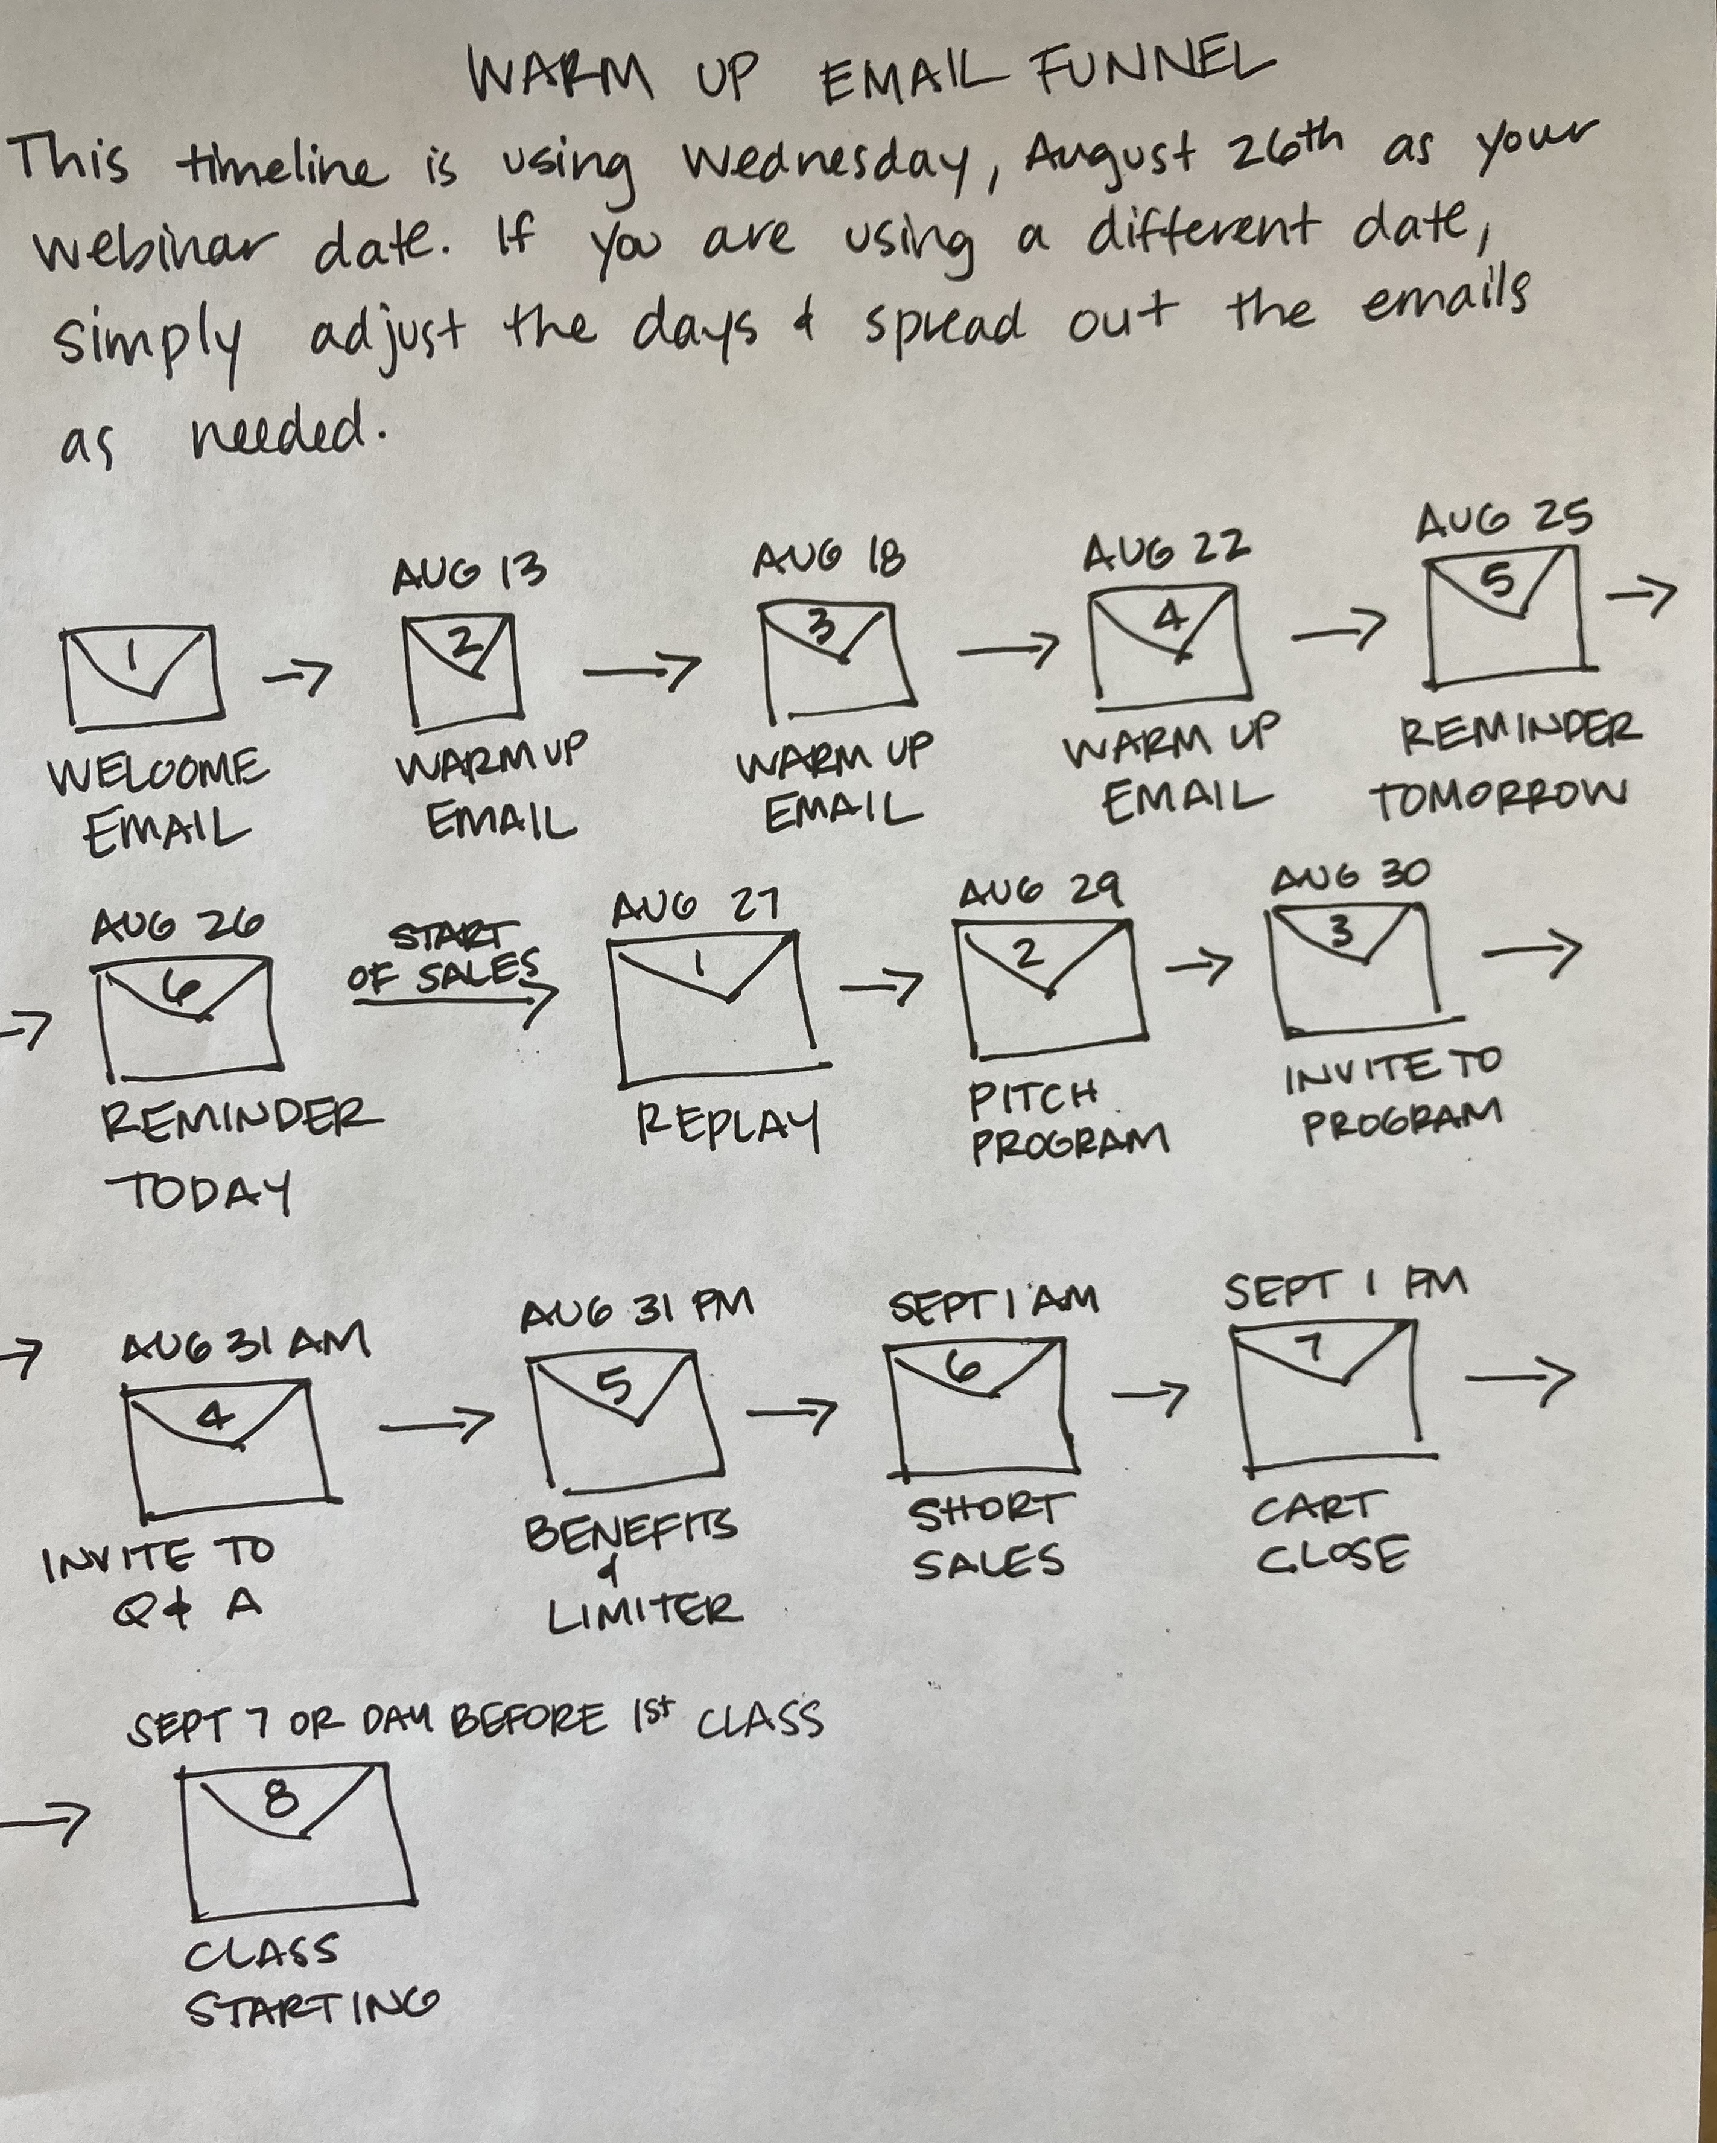Remember when you are writing an email funnel you want to:
- Address your clients’ pain points and how that relates to your promise and benefits
- Overcome any objections your client may have around coming to your webinar or buying into the idea of your promise in general
- Write in conversational everyday language like you are speaking to your best friend over coffee. Do not use practitioner speak!
- Mix up the type, length and style of your emails. Notice how we re-use some info without making it seem like it’s exactly the same.
- Add a tantalizing subject line for each email
- Don’t forget to add a fun royalty free photo in your emails!

You’ll need to calculate the length of your warm up sequence based on the time between when you start inviting participants to register and the day of your webinar.

WARM-UP/REMINDER FUNNEL OUTLINE
Here is the general format of a Warm-up/Reminder Sequence for a Webinar:

Email 1: Welcome/Delivery Email with Webinar Details
Email 2: Warm up with Education-based marketing + Share Story + Invite to Facebook Group for webinar
Email 3: Warm up with more education-based marketing
Email 4: Warm up with more education-based marketing
Email 5: Webinar Tomorrow Reminder
Email 6: Webinar Today Reminder
(Note: You’ll send the replay in your sales sequence.)

We’ve given you examples of each kind of email sequence below so you have a template to write your own. Make sure you pay attention to editing dates, links and times.
_____________________________________________________________

Welcome Email
After you set up your challenge landing page, you need to connect it to your welcome email which is the first email in your warm-up funnel. In this email, you are going to give your participants the basic information and confirming that they are registered for your webinar.

Subject: You're IN! Thanks for registering for our Retreats Made Easy Training!

Dear [contact],
Aren’t you savvy? You're all registered for our:
RETREATS MADE EASY
How to Create Your First Sold-Out Retreat LIVE Webinar Training!

Simply click on this link to start the webinar: [insert link to webinar]

Here are your webinar details: Friday, August 17th 12pm New York, 9am Los Angeles,
5pm London

Simply click here [insert timeconverter link] to use this nifty tool to convert the time for your timezone. Set your calendar alert and we'll see you there!

In the meantime, we’d love for you to pop over to our private Facebook Group were we’ll be sharing lots of tips and resources! [insert FB Community Group link]

To your wanderlust life, Sheri & Meghan & the Wanderlust Team

Warm Up Email Funnel Template
This warm up email funnel starts with your welcome email. You then add in some “warm up” emails to get your participants excited about your webinar, educating them on their pain points. This keeps them engaged between the time they register and the actual start of the webinar.

Then you want to send them reminder emails for the webinar as well as replay emails after.

EMAIL 1: Your Welcome Email (see above)

WARM UP EMAIL 2: Education-based marketing + Share Story + Invite to Facebook Group
We decided to create some bonus training videos before the webinar – you can simply address pain points in your email text if you don’t plan on making videos.

Subject: [Bonus Training] How to Make Your First Retreat KICKASS

I'll never forget my first retreat with shaman and international best-selling author of The Four Agreements, don Miguel Ruiz. As I stood on top of he Pyramid of the Sun in Mexico, I knew my life would never be the same. And I knew I wanted to help others do the same.

And I know that if you're here with me today that you're dreaming of running your own transformational retreats and you want to start locally or in your own country - which is awesome!

Now the BEST way to get started is by becoming 100% clear on what a transformational retreat is.

Because unfortunately, most folks structure their retreat just like a workshop - and that can be the kiss of death for your first retreat!

So while you're waiting for our upcoming webinar training - we've created THREE special mini-trainings for you to get you warmed up!

And the first mini-training is on How to Make Your First Retreat KICKASS Fabulous!

Here's how to join this bonus mini-training:
- Watch our training on the website. [insert link to training]
- Then come on over to our private Facebook Group and post what you think!

To get into our group simply click the BLUE BUTTON below that says "+ Join Group" and
we'll let you into the group shortly! [insert FB Group Link]

If you are already in our group - awesome!
To your wanderlust life, Sheri + Meghan + The Wanderlust Team

WARM UP EMAIL 3: More education-based marketing
We decided to create some bonus training videos before the webinar – you can simply address pain points in your email text if you don’t plan on making videos.

Subject: [BONUS TRAINING 2] Location Matters! Even with Local Retreats

Dear [contact],
Choosing a location is really important – even if you're running your retreat locally.

It’s critical to think about how your retreat attendees are going to perceive the place you pick – because this is going to affect your brand, what people feel you are worth, and how much you can charge for your retreat.
Even if you live in a small town that's not what folks might consider a "resort or vacation location" - you can still create a beautiful retreat that folks will be excited about attending.

Want to hear more?

While we're waiting for our awesome webinar training - we've created THREE special Facebook Livestream mini-trainings for you to get you started!

And the second mini-training is on Location Matters! Even with LOCAL Retreats. Here's how to join this bonus mini-training:
1. Watch our training on the website. [insert link to training]
2. Then come on over to our private Facebook Group and post what you think!

To get into our group simply click the BLUE BUTTON below that says "+ Join Group" and we'll let you into the group shortly! [insert link to FB Community Group]

If you are already a member - no worries - just come on in!

To your wanderlust life, Sheri + Meghan + the Wanderlust Team

PS: Access our FIRST bonus training here in case you missed it! [insert link to first training]

WARM UP EMAIL 4: More education-based marketing
We decided to create some bonus training videos before the webinar – you can simply address pain points in your email text if you don’t plan on making videos.

Subject: [BONUS TRAINING 3] The Super Simple Way to Start Your Retreat Marketing

Dear [contact],
Feeling a little overwhelmed about how you'll ever grow a big enough list of people to be able to offer your first retreat? No worries - we have the super simple solution.

Most retreat leaders, even experienced ones, make the mistake of trying to sell their retreat by telling people that they have a retreat coming up and would they please join them.

But that's a major boo-boo because people don’t care about us, they care about themselves and their own problems and issues.

If you focus on how your retreat will solve their problems and issues – they'll be excited to join you because you're helping them.

And if you learn how to talk about the benefits your retreat offers, you’ll be a better marketer than the majority of retreat leaders out there having trouble filling their retreats!

It's really easy once you get the hang of it! Let us show you how...

So while you're waiting for our awesome webinar training - we've created THREE special Facebook Livestream mini-trainings for you to get you started!

The third bonus training is on The Super Simple Way to Start Your Retreat Marketing! Here's how to join this bonus mini-training:
1. Watch our training on the website. [insert link to training]
2. Then come on over to our private Facebook Group and post what you think!
To get into our group simply click the BLUE BUTTON below that says "+ Join Group" and we'll let you into the group shortly! [insert link to FB Community Group]

If you're already a member of our group - simply come on in!
To your wanderlust life, Sheri + Meghan + the Wanderlust Team

PS: You can access your FIRST training here in case you missed it and want to catch up! [insert link to first training]
And here's our SECOND training too. [insert link to second training]
REMINDER EMAIL 5: Webinar Tomorrow Reminder

Subject: The Wait is Almost Over! Retreats Made Easy TOMORROW

Dear [contact],

Do you have as much on your mind as we do? Thought so… so here's a reminder! Do a Happy Dance! TOMORROW is our webinar training:

RETREATS MADE EASY
How to Create Your First Sold-Out Retreat Webinar Training!

Time & Date:
Friday August 17th at 12pm New York time, 9am Los Angeles,
5pm London

Not sure what time it is where you live?
Simply click here to use this nifty tool to convert the time for your timezone. [insert timeconverter link]

Click here to join us tomorrow: [insert link to join webinar]

To your wanderlust life, Sheri & Meghan & the Wanderlust Team

PS: It's best to watch on your computer so you can see the slides (especially since we really tried to make them pretty!).

REMINDER EMAIL 6: Webinar Today Reminder
Subject: It’s Webinar DAY! Time to Create Your First Retreat!

Dear [contact],

Tie up the kids! Lock up the dog! :)

Grab your cup of tea, coffee or smoothie and get ready for the webinar!

Click here to join us:
[insert link to join webinar]

It's best to watch on your computer so you can see the slides, which are quite lovely if we do say so ourselves.

Here are today's deets - it's almost time!

RETREATS MADE EASY
How to Create Your First Sold-Out Retreat Webinar Training!

Time & Date:
Friday August 17th at 12pm New York time, 9am Los Angeles,
5pm London
Not sure what time it is where you live?

Simply click here to use this nifty tool to convert the time for your timezone. Click here to join us today: [insert timeconverter link]

To your wanderlust life, Sheri & Meghan & the Wanderlust Team

REMINDER 7: Webinar in 1-Hour Reminder
Subject: [GOING LIVE] How to Create Your FIRST Transformational Retreat!

Dear [contact],

Got your pen and pad of paper? Had a chance to pee? :-) Grabbed your coffee, tea or chocolate? I hope so because you're in for a treat!

This is your link to join us in an hour!

Here are the deets - we're going LIVE soon!

RETREATS MADE EASY
How to Create Your First Sold-Out Retreat Webinar Training!

Time & Date:
Friday, August 17th at 12pm New York time, 9am Los Angeles,
5pm London
Click here to join us:
[insert link to join webinar]

To your wanderlust life, Sheri & Meghan & the Wanderlust Team

NOW YOUR TURN:

STEP 1: Using the Warm Up Email Template as your example, you’ll now write out your own email funnels.

Don’t get fancy – just use our template and replace your info with ours!

HOT TIPS: Get your Welcome Email set up first. Then you can add in your Warm-Up emails. Take them step-by-step.

Remember you can use the wording you came up with on for your online program, webinar pain points and benefits and the advertising bullet points in the email funnels.

We find it’s helpful to bullet point the main topics you’ll cover within each email. You might want to start by scribbling out your sequence on a whiteboard or piece of paper and organizing all your ideas together.

STEP 2: After you receive our thumbs up, you need to upload your emails into your autoresponder.

If you have any questions, please let us know!

