What is an Email Funnel?
Explanation, Instructions & Prep!

So what is an email funnel or email sequence? Basically, it is a series of pre-written emails designed for a specific outcome. They are pre-programed in advance and loaded into your autoresponder to be sent out to your list on pre-determined dates.

There are different types of email funnels and depending on your goals and situation (such as whether you have an email list already or not) so you are going to need to write multiple separate email funnels and upload them into your autoresponder.

You can then connect these email funnels together and move participants from one to the next depending on whether they register for your challenge, webinar or event – or for your online program.

For this course, you are writing a series of email in order to let people know about your challenge, webinar or 3-day event – and also your online program.

In this document, we’re explaining what an email funnel is and giving you an overview of each type of email funnel. To actually create your email funnels using our templates, you’ll then want to use:

FOR THOSE OF YOU DOING CHALLENGES:
Challenge WARM UP Email Funnel Template:
https://howtocreatearetreat.s3.amazonaws.com/marketing-mastery/WARMUPChallengeEmailFunnelTemplateMMA.docx

Challenge INVITE Email Funnel Template:
https://howtocreatearetreat.s3.amazonaws.com/marketing-mastery/INVITEChallengeEmailFunnelTemplateMMA.docx

Challenge SALES Email Funnel Template:
https://howtocreatearetreat.s3.amazonaws.com/marketing-mastery/SALESChallengeEmailFunnelTemplateMMA.docx

FOR THOSE OF YOU DOING WEBINARS:
Webinar WARM UP Email Funnel Template:
https://howtocreatearetreat.s3.amazonaws.com/marketing-mastery/SALESWebinarEmailFunnelTemplateMMA.docx

Webinar INVITE Email Funnel Template:
https://howtocreatearetreat.s3.amazonaws.com/marketing-mastery/SALESWebinarEmailFunnelTemplateMMA.docx

Webinar SALES Email Funnel Template:
https://howtocreatearetreat.s3.amazonaws.com/marketing-mastery/SALESWebinarEmailFunnelTemplateMMA.docx

ONCE SOMEONE HAS PURCHASED YOUR ONLINE PROGRAM:
Buyers DELIVERY Email Funnel Template:
https://howtocreatearetreat.s3.amazonaws.com/marketing-mastery/BUYERSDELIVERYEmailFunnelTemplateMMA.docx

Remember when you are writing an email funnel you want to:
- Address your clients’ pain points and how that relates to your promise and benefits
- Overcome any objections your client may have around coming to your challenge or buying into the idea of your promise in general
- Write in conversational everyday language like you are speaking to your best friend over coffee. Do not use practitioner speak!
- Mix up the type, length and style of your emails. Notice how we re-use some info without making it seem like it’s exactly the same.
- Add a tantalizing subject line for each email
- Don’t forget to add a fun royalty free photo in your emails!

Let’s take a look at the various types of emails and email funnels that you’ll need to create. These are UNIQUE funnels that need to be uploaded into your autoresponder separately.

EMAIL FUNNEL 1: WARM UP EMAIL FUNNEL
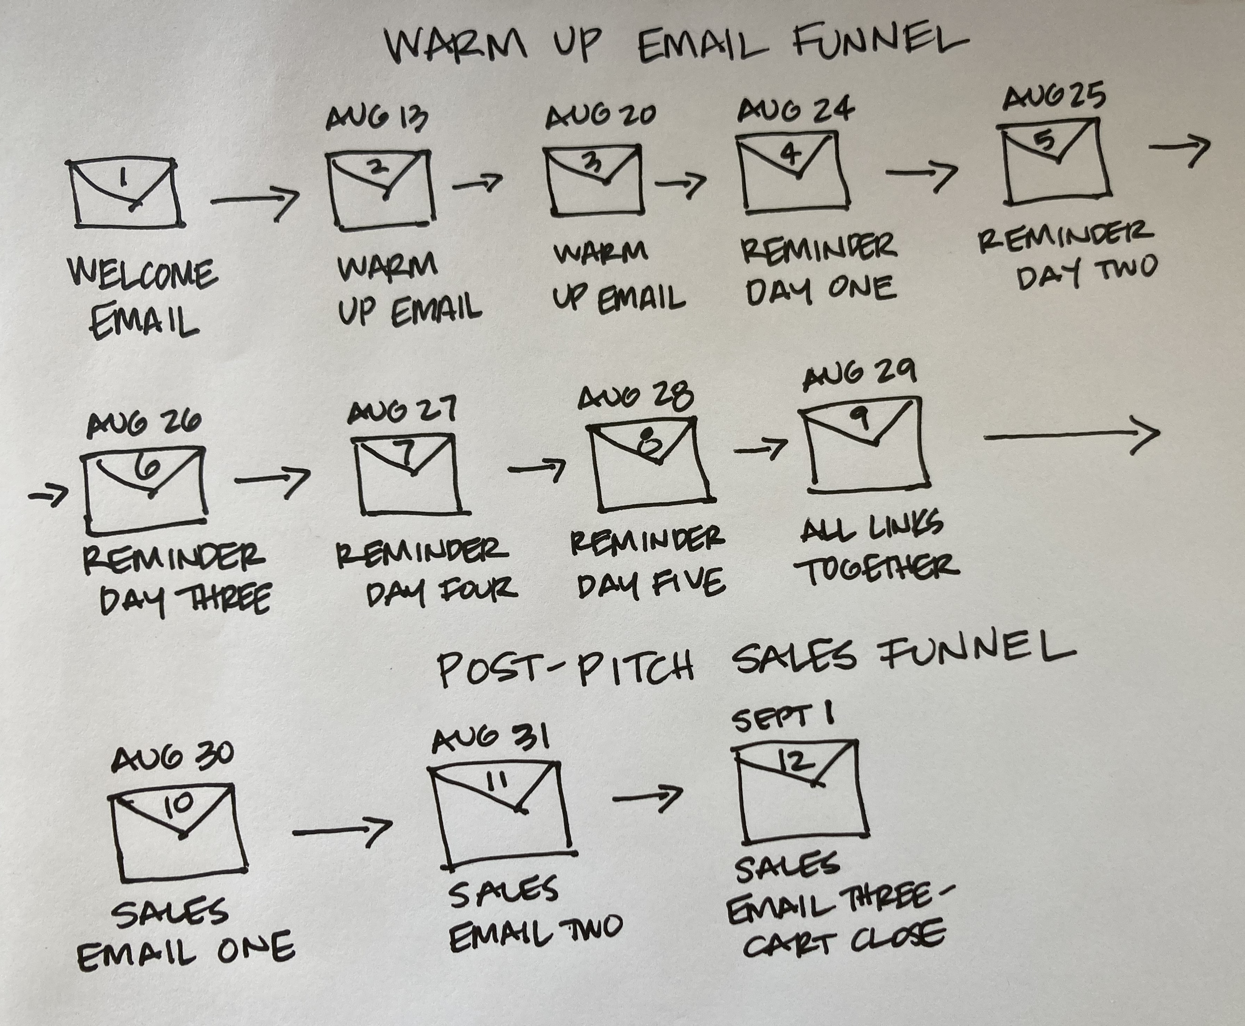
Welcome Email
Once someone goes to your landing page and they register for your challenge, webinar or event, they get redirected to your thank you page AND the first email they receive is your welcome email.

For everyone, you need to create the welcome email that your challenge (or webinar or 3-day event or retreat) participants will get when the sign up.

Why? Because as soon as you have your landing page, thank you page and welcome email written and uploaded into your autoresponder, you can start to let potential participants know about your challenge, webinar or event – it’s critical to get this up and running even if you don’t have the rest of your email funnels else in place!

In this welcome email, you are giving them the very most basic information about your challenge, webinar or event. Don’t get fancy – just follow what we have in the WARM UP Email Funnel Template!

Warm-Up Email Funnel (also called your Challenge Delivery or Content Delivery Funnel)
For everyone, you then need to work on the emails you are sending out to anyone who registers for your challenge (or webinar or 3-day event or retreat) to keep them engaged from the time they sign up to until you actually do your challenge (or webinar or 3 day event or retreat.)

Then you’ll want to send them reminders for each day of the challenge (or webinar or 3 day event or retreat) to encourage their participation, plus one on day 6 that has all the challenge Livestream links in one place.

After the reminder emails, you’ll then send a few post-pitch sales emails to share the details of your online program. Again, these sales emails do NOT need to be in place to set up your warm-up email funnel. You can add these in later on, step-by–step.

You’ll need to calculate the length of your warm up sequence based on the time between when you start inviting participants to register and the first day of your challenge. We’ve given you suggested dates in the visual pictures of the funnels.
Remember – folks are going to be coming into your warm up email in two ways. If you have a list and invite them, they can sign up on your landing page and then they’ll get the welcome email and warm up email funnel.

The second way is coming in through social media, which is going to be the primary method if you do not have a list.

EMAIL FUNNEL 2: INVITE EMAIL FUNNEL
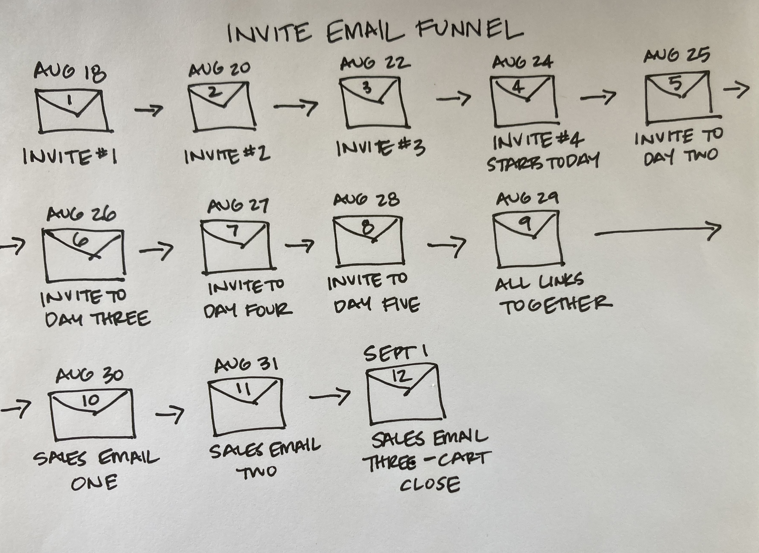
Re-Engagement Email
If you have a list and you haven’t communicated with them in a long time OR you have changed your avatar/promise/niche OR you “scraped together a list” of friends/clients/family, then you need to send a re-engagement email.

In this email, you are “re-engaging” with your community by letting them know what you are currently up to and getting them excited about your business.

You can send this out as a newsletter/e-blast or include it as the first email in your invite email funnel. Send this out ASAP! You’ll see an example of this email in the INVITE Email Funnel Template.

Invite Email Funnel
If you have a list, you need to create a set of emails to your list inviting them to your challenge (or webinar or 3-day event or retreat.) You’ll hit on their pain points and share your pre-launch warm-up strategy advertising bullet points along with how to register for your challenge, webinar or event.

You’ll be emailing your list all through the challenge whether they register or not – after all not everyone opens every email and some people need to hear about it multiple times before they take action. You can essentially edit your reminder emails from your warm-up email funnel for these.

You’ll then send a few post-pitch sales emails to share the details of your online program even if they didn’t register for the challenge or webinar itself. Some folks will be happy to just jump in to your program!

Again, these sales emails do NOT need to be in place to set up your invite email funnel. You can add these in later on, step-by–step.

You’ll start inviting your list about a week before the challenge starts – we’ve noted the dates in the visual map.

CRITICAL!! Make sure that once someone DOES registers for your challenge, webinar or event that you take them out of this funnel and put them into the Welcome/Warm-Up Email Funnel. Once they’ve said, “yes I’m in!” it’s considered bad email practices to keep inviting them – and they now need the welcome and warm up info details.

CRUCIAL EMAIL FUNNEL ADD ON: POST-PITCH SALES EMAIL FUNNEL

POST-PITCH SALES EMAIL FUNNEL (also called a Sales Funnel)
At the end of both your Warm-Up Email Funnel and your Invite Email Funnel, you will send a series of sales emails to invite folks to join your online program.

For your Warm-Up Email Funnel, you’ll send these after your pitch to invite your challenge or webinar participants to join your online program with the link to your online program sales page. You’ll want to reference what you’ve been talking about in your challenge or webinar so it makes sense why your online program is the next logical step.

If you have a list, you will send a variation of this same post-pitch sales email funnel at the end of your Invite Email Funnel. These folks did NOT participate in the challenge or webinar but they might still want to join your program. It is essentially the same emails as the ones from your Warm-Up Email Funnel without references to your challenge or webinar.

If you look at each visual map above, you can see how these emails have been added on to the end of each email funnel.

Do make sure that once you add these into your autoresponder that you re-publish it so all your changes are saved and these new emails will be triggered to be sent.

EMAIL FUNNEL 3: BUYERS DELIVERY EMAIL FUNNEL TEMPLATE
This is the most exciting email funnel of all – it’s the one that welcomes folks into your online program, which means you’ve made sales!

You’ll want to explain the details of the “next steps” after registering for your program. Depending on what you included in your online program that might include coming into your Buyer’s Facebook Group, marking the dates of group calls on their calendar, scheduling a 1:1 session with you or logging into your online program.

It’s also smart to send reminder emails for each live group call you have to keep people re-engaged. Remember that the more folks participate in your program, the more success they’ll have – which means less cancellations and more testimonials for you.

You may also want to send out replay emails with homework reminders after each call.

CRITICAL! You’ll want to make sure that as soon as anyone BUYS your online program that they are taken out of your WARM-UP or INVITE Email Funnel because they no longer need to receive any more sales emails.

NOW WHAT?

STEP 1: Using the Warm Up Email Template, Invite Email Template, Sales Email Template and Buyer’s Delivery Email Template as examples, you’ll now write out your own email funnels.

Don’t get fancy – just use our template and replace your info with ours!

HOT TIPS: You don’t need to write all the email templates at once. Take them step-by-step.

Remember you can use the wording you came up with on for your online program, challenge/webinar pain points and benefits and the advertising bullet points in the email funnels.

We find it’s helpful to bullet point the main topics you’ll cover within each email. You might want to start by scribbling out your sequence on a whiteboard or piece of paper and organizing all your ideas together.

STEP 2: After you receive our thumbs up, you need to upload your emails into your autoresponder.
If you have any questions, please let us know!

